**Part 2: System Design & Models**

**8) Functional Requirements**

**a) Use-Case Diagram**

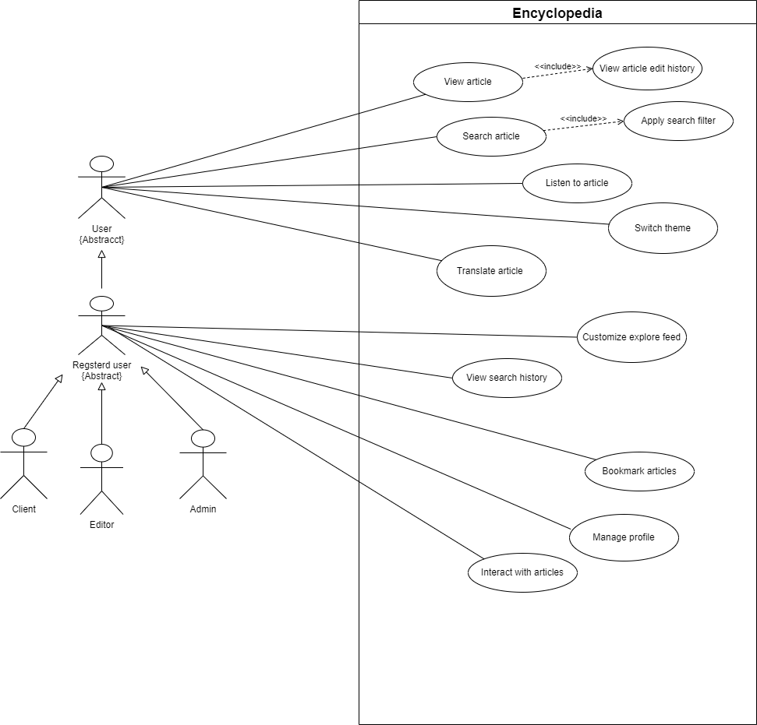

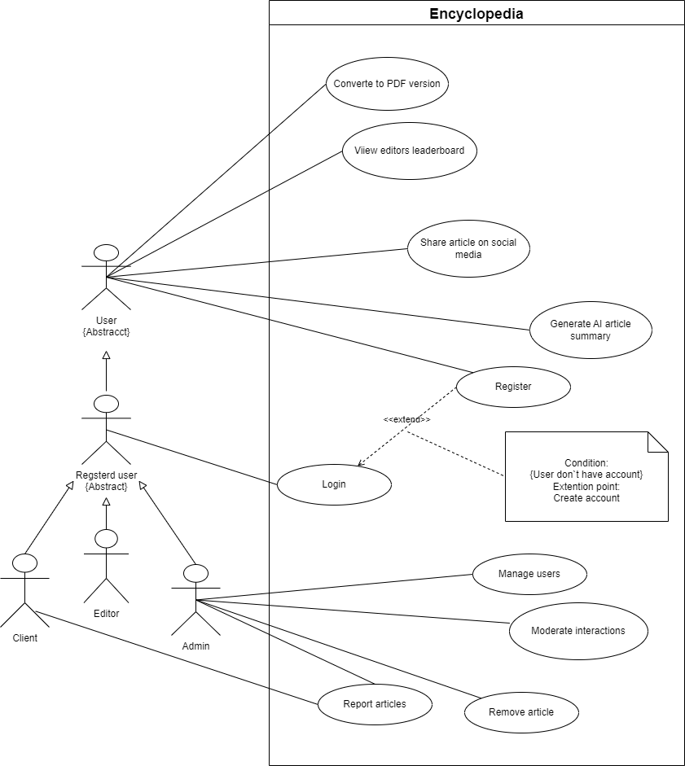

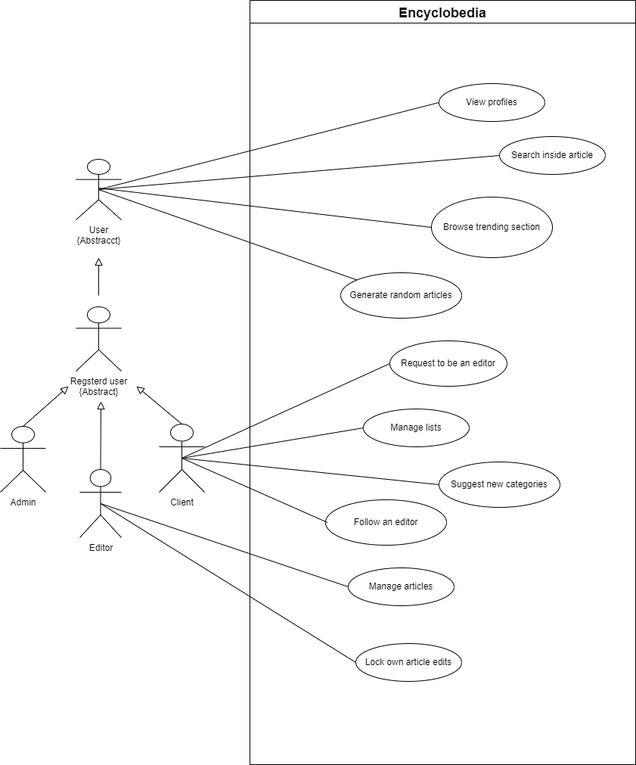

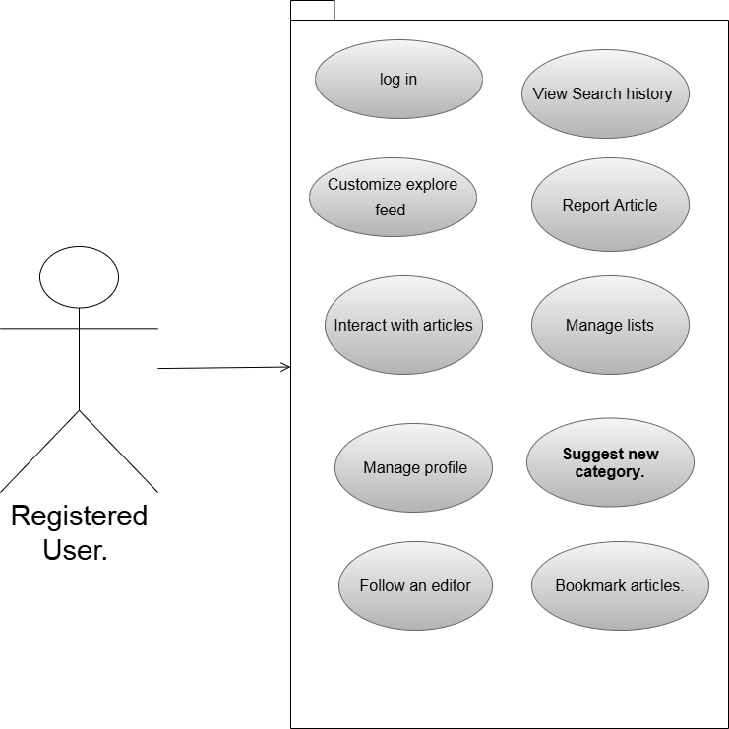

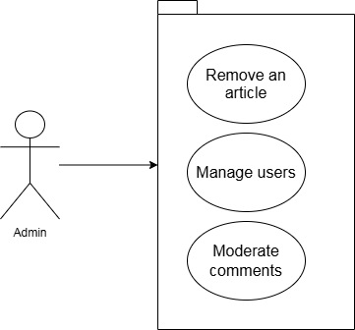

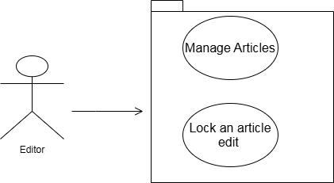

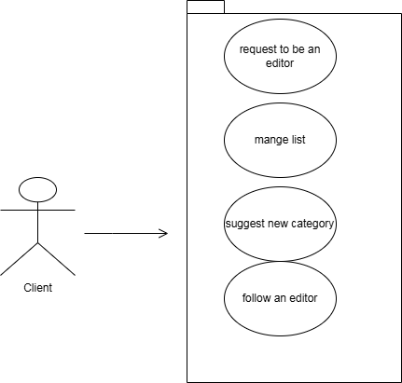

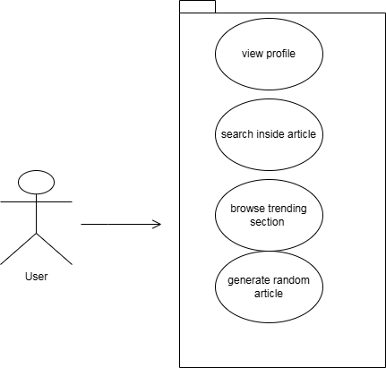

**b) Detailed Use-Cases Description**

**Use Case Description**

|  |  |
| --- | --- |
| **ID-Number – Name:** | UC-1 -- Login |
| **Short-Description / Goal:** | Allows a registered user to securely access their account and personalized features such as bookmarks, history, and custom feeds. |
| **Preconditions:** | The user has already registered, has valid login credentials, and is not logged in. |
| **Postconditions:** | User is authenticated and redirected to the homepage. A session is created for the user. |
| **Error Situations – System**  **State in case of an Error:** | User submits incorrect email or password – A message “Incorrect username or password” is displayed. |
| **Actor (s) / Initiator (s):** | Registered User. |
| **Trigger:** | The User clicks on the “login” button. |
| **Standard Process (Main Success Scenario):** | 1. User clicks the “login” button 2. System displays the login form requesting username and password 3. User enters their credentials and submits the form 4. System verifies the credentials and redirects the user to the homepage. |
| **Alternative Processes**  **(Alternative/Other Scenarios):** | (3’) User enters wrong credentials  (4’) System displays “Incorrect credentials”. |
| **Extension (Extended Use Case)** | * **Condition:**  User does not have an account * **Extension Point:** From the login page, the user clicks on the (Register) button * **Extended Steps:**  1. System displays the registration form requesting username, email, password, and optional profile info 2. User fills in required information and submits 3. System validates the input (email format, username uniqueness, etc.) 4. If valid, system creates a new user account and stores it 5. System logs in the user automatically  * **Failure Conditions in the Extension:**  1. Username already exists: System makes the user choose another |

|  |  |
| --- | --- |
| **ID-Number – Name:** | UC-2 – Switch theme. |
| **Short-Description / Goal:** | This use case describes how the user can change the theme from light mode to dark mode and vice versa to customize their reading experience. |
| **Preconditions:** | The main page is displayed. The user is provided with a button to switch themes. |
| **Postconditions:** | The interface is updated with the newly selected theme (dark or light). |
| **Error Situations – System**  **State in case of an Error:** | **Theme switch fails** – The system displays an error message “Unable to apply theme, please try again.” |
| **Actor (s) / Initiator (s):** | User. |
| **Trigger:** | The user clicks on the theme exchange button to change the theme of the system. |
| **Standard Process (Main Success Scenario):** | 1. The system provides the user with a button to change the theme. 2. The user clicks the button to change the theme. 3. The system loads the change selected by the user (dark or light). 4. The system displays the new theme. |
| **Alternative Processes**  **(Alternative/Other Scenarios):** | **Theme already applied:** if the theme is already active, the system does not change any theme on the website. |

|  |  |
| --- | --- |
| **ID-Number – Name:** | UC-3 – View Article |
| **Short-Description / Goal:** | Allow users to access and read content from the encyclopedia with multilingual versions. |
| **Preconditions:** | Article exists in the DB. The Article must be available in the selected language |
| **Postconditions:** | The User successfully views the full content of the article. |
| **Error Situations – System**  **State in case of an Error:** | Article content fails to load due to a DB error and the system displays an error message “Article not found”. |
| **Actor (s) / Initiator (s):** | User |
| **Trigger:** | User selects an article from the search, feed, or his bookmarks. |
| **Standard Process (Main Success Scenario):** | 1. User selects an article 2. System brings the article content from the DB 3. The system displays the article in a readable format with title, content, body, etc. 4. If the article is available in multiple languages, a language selector is shown 5. User scrolls or reads the article |
| **Alternative Processes**  **(Alternative/Other Scenarios):** | (2’) When the user tries to select an article. The Article isn't found |

|  |  |
| --- | --- |
| **ID-Number – Name:** | UC-4 -- Customize explore feed |
| **Short-Description / Goal:** | Allow users to personalize their explore feed by selecting a category. |
| **Preconditions:** | User is logged in. |
| **Postconditions:** | User's preferences are saved. The explore feed is updated to reflect the selected category. |
| **Error Situations – System**  **State in case of an Error:** | Preferences fail to save due to a session error – “Error in saving preferences, try again later” |
| **Actor (s) / Initiator (s):** | Registered User. |
| **Trigger:** | User clicks on (Customize feed) from the explore page |
| **Standard Process (Main Success Scenario):** | 1. User clicks (Customize Feed) 2. System displays a settings interface with available categories 3. User selects the category 4. User clicks (submit) 5. Explore feed updates based on saved preferences |
| **Alternative Processes**  **(Alternative/Other Scenarios):** | (3’) When the user selects his preferences, he chooses not to select a category (System displays some random articles) |

|  |  |
| --- | --- |
| **ID-Number – Name:** | UC-5 – Listen to article |
| **Short-Description / Goal:** | On click from the user to start the system reader, the system starts to read the article |
| **Preconditions:** | The article must be loaded in readable text format in the user's browser and the speaker button is visible and clickable. |
| **Postconditions:** | The article audio is successfully played |
| **Error Situations – System**  **State in case of an Error:** | Device has no audio device – Sound is not played |
| **Actor (s) / Initiator (s):** | User |
| **Trigger:** | User clicks on the speaker icon |
| **Standard Process (Main Success Scenario):** | (1) The article loaded in a readable text format.  (2) The user clicks on the speaker icon.  (3) The system reader starts to read the article until the article is finished, or the user stops the reading process. |
| **Alternative Processes**  **(Alternative/Other Scenarios):** | (1`) The article isn’t loaded in readable text format.  (4`) The system displays connection error. |

|  |  |
| --- | --- |
| **Name:** | **UC-6-Translate Articles.** |
| **Description:** | This use case describes how users can view the same article in different languages as per their preferred language. |
| **Preconditions:** | * The user is viewing an article. * The language is supported by the system. |
| **Postconditions:** | * The article content is displayed in the user’s selected language. |
| **Error Situations – System**  **State in case of an Error:** | **Unsupported language**: if the selected language is not supported by the system, the system does not display it. |
| **Actor (s) / Initiator (s):** | User |
| **Trigger:** | The user selects a language from the list of supported languages by the system. |
| **Standard Process (Main Success Scenario):** | 1. The system displays the article to the user. 2. The user clicks on the language list. 3. The system shows a list of available languages. 4. The user selects one from them. 5. The system displays the article in the selected language. |
| **Alternative Processes**  **(Alternative/Other Scenarios):** | (5′) The user switches back to the original language.  (6′) The system displays the original article. |

|  |  |
| --- | --- |
| **ID-Number – Name:** | UC-7 Generate PDF report |
| **Short-Description / Goal:** | Generate a PDF report |
| **Preconditions:** | The user must be an admin. |
| **Postconditions:** | A pdf having the report has been successfully generated |
| **Error Situations – System**  **State in case of an Error:** | Generation failed – The system won’t create the pdf. |
| **Actor (s) / Initiator (s):** | Admin |
| **Trigger:** | The admin clicks on generate report. |
| **Standard Process (Main Success Scenario):** | 1. The admin clicks on the generating button 2. The system returns a pdf with users and articles count. |
| **Alternative Processes**  **(Alternative/Other Scenarios):** | (1’) Pdf generation fails  (2’) Pdf won’t be created. |

|  |  |
| --- | --- |
| **ID-Number – Name:** | UC-8 – Interact with articles |
| **Short-Description / Goal:** | A user can like and comment on articles. |
| **Preconditions:** | User is logged in to the system. |
| **Postconditions:** | An interaction is added to an article. |
| **Error Situations – System**  **State in case of an Error:** | The user is trying to interact with an already deleted article – No interactions saved. |
| **Actor (s) / Initiator (s):** | Registered User |
| **Trigger:** | User clicks one of the interaction buttons (Voting or commenting). |
| **Standard Process (Main Success Scenario):** | (1) User interacts with an article.  (2) System saves the interaction and displays it. |
| **Alternative Processes**  **(Alternative/Other Scenarios):** | (2’) System didn’t find the article. (article is deleted)  (3’) No interaction saved. |

|  |  |
| --- | --- |
| **ID-Number – Name:** | UC-9 – Bookmark articles. |
| **Short-Description / Goal:** | User can collect articles in bookmark list. |
| **Preconditions:** | User is logged in to system |
| **Postconditions:** | The article is added to the user's list of bookmarked articles |
| **Error Situations – System**  **State in case of an Error:** | Bookmarking after logging out – The system displays “Unauthorized” |
| **Actor (s) / Initiator (s):** | Registered user |
| **Trigger:** | User clicks on bookmark. |
| **Standard Process (Main Success Scenario):** | 1-User chooses the article they want to bookmark.  2-The user clicks on the "Bookmark" icon or button.  3-System adds the articles to bookmarks. |
| **Alternative Processes**  **(Alternative/Other Scenarios):** | (1’) The user decides to remove a previously bookmarked article.  (3’) Article removed from bookmarks list. |

|  |  |
| --- | --- |
| **ID-Number – Name:** | UC-10 View articles edit history |
| **Short-Description / Goal:** | Enables users to view the edit history of the article’s editor. |
| **Preconditions:** | Articles must exist in the database.  Articles must be unlocked. |
| **Postconditions:** | The user is provided with an article’s whole edit history display. |
| **Error Situations – System**  **State in case of an Error:** | Articles have been locked – System blocks access. |
| **Actor (s) / Initiator (s):** | User |
| **Trigger:** | User click to view edit history button. |
| **Standard Process (Main Success Scenario):** | 1-The user clicks on the "View Edit History" button.  2-The system fetches the edit history from the database.  3-The system displays a list of all edits, including:   * Timestamp of each edit. * The user who made the edit. * Changes made to the article |
| **Alternative Processes**  **(Alternative/Other Scenarios):** | (3) database failed to retrieve edit history.  (4) No edit history displayed. |

|  |  |
| --- | --- |
| **ID-Number – Name:** | UC-11 -- Report Article |
| **Short-Description / Goal:** | Allow users to report an article for issues like misinformation, … etc) |
| **Preconditions:** | User is logged in and the article to be reported exists and is accessible |
| **Postconditions:** | Report submitted and saved in the system for admin review. A confirmation is shown to the user |
| **Error Situations – System**  **State in case of an Error:** | System fails to save the report. – System displays “There was a problem in sending your report, please try again.” |
| **Actor (s) / Initiator (s):** | Client/Editor |
| **Trigger:** | User clicks (report) on an article while viewing it. |
| **Standard Process (Main Success Scenario):** | 1. User clicks the (Report Article) button 2. The system opens a reporting form with selectable reasons (eg. spam) and an optional comment box 3. User selects a reason, optionally adds a comment, and submits the report 4. System saves the report in the DB 5. System confirms submission and informs the user that the report was received |
| **Alternative Processes**  **(Alternative/Other Scenarios):** | (4’) System fails to save report  (5’) System displays “There was a problem in sending your report, please try again.” |

|  |  |
| --- | --- |
| **ID-Number – Name:** | UC-12 – Manage Articles |
| **Short-Description / Goal:** | Allow editors to create and modify articles |
| **Preconditions:** | **In the case of creating a new article:** The user must be an editor.  **In case of editing the article:** The Article must exist and must be accessible for editing. |
| **Postconditions:** | **In case of Creating a new article:** A new Article is saved in the systems DB. The Article becomes available for viewing it  **In case of editing the article:** The Updated article is saved and stored. Changes made are visible to readers.  **In case of deleting the article:** The article must be available. |
| **Error Situations – System**  **State in case of an Error:** | A non-editor tries to add an article – The system redirects to the login page. |
| **Actor (s) / Initiator (s):** | Editor |
| **Trigger:** | The Editor clicks (Create New Article / Edit) button |
| **Standard Process (Main Success Scenario):** | **In case of creating an article:**   1. Editor clicks on (Create Article) 2. System displays a form with fields like title, content, and category. 3. Editor fills in all required details 4. Editor clicks (save) 5. System validates inputs 6. System saves the article to the DB 7. Editor is redirected to the newly created article   **In case of editing an article:**   1. Editor clicks (Edit) on the Article 2. System loads the article content on the editor interface 3. Editor makes changes in (content) 4. Editor clicks (save) 5. System validates the content 6. System saves the updated version   **In case of deleting an article:**   * + - 1. The editor clicks on delete icon       2. System deletes article. |
| **Alternative Processes**  **(Alternative/Other Scenarios):** | **In case of editing an article:**   * + - 1. The editor cancels the process |

|  |  |
| --- | --- |
| **ID-Number – Name:** | UC-13 – Manage lists |
| **Short-Description / Goal:** | The user can manage lists by creating new lists, accessing their lists, or delete a list. |
| **Preconditions:** | Users must specify list name |
| **Postconditions:** | The list is updated in the database |
| **Error Situations – System**  **State in case of an Error:** | The database fails – Lists did are not modified |
| **Actor (s) / Initiator (s):** | Registered User |
| **Trigger:** | User want is to (Create, Read, Update, Delete) list |
| **Standard Process (Main Success Scenario):** | (1) The user enters the lists page. Or inside the article clicks “add to list” button.  (2) The user selects what he wants to do  (Create, Read, Update, Delete)  (3)The system saves the lists or the articles to the DB. |
| **Alternative Processes**  **(Alternative/Other Scenarios):** | (3’) DB failed  (4’) No list update. |

|  |  |
| --- | --- |
| **ID-Number – Name:** | UC-14 – Share articles on social media |
| **Short-Description / Goal:** | Users can share articles on their social media account. |
| **Preconditions:** | The article is available. |
| **Postconditions:** | User is at the “Write Post” section on the selected social media platform with the article’s link prefilled. |
| **Error Situations – System**  **State in case of an Error:** | Social media API failed – A “Try again later” message is displayed. |
| **Actor (s) / Initiator (s):** | User |
| **Trigger:** | User clicks on the “Share Article” button. |
| **Standard Process (Main Success Scenario):** | 1. User clicks on share article button 2. Social media API processes the request 3. The article’s link appears in the “Write Post” section of the selected social media platform. The user can then choose whether to post or cancel. |
| **Alternative Processes**  **(Alternative/Other Scenarios):** | (2’) Social media API failed.  (3’) A “Try again later” message is displayed. |

|  |  |
| --- | --- |
| **ID-Number – Name:** | UC-15 – Generate AI summary |
| **Short-Description / Goal:** | On request from the user the system can generate a summary of the article using AI. |
| **Preconditions:** | The full article text must be available and accessible for processing |
| **Postconditions:** | The system generates a summarized version of the article and displays it for the user to view or use |
| **Error Situations – System**  **State in case of an Error:** | AI did not respond to the request – Summary is not generated |
| **Actor (s) / Initiator (s):** | User |
| **Trigger:** | User request to generate summary for an article |
| **Standard Process (Main Success Scenario):** | (1) The user clicks to generate article summary.  (2) The AI generates a summary of the article.  (3) The system displays this summary to the user |
| **Alternative Processes**  **(Alternative/Other Scenarios):** | (1`) This option does not exist in the article wanted.  (2`) The system will display this option locked to the user. |

|  |  |
| --- | --- |
| **Name:** | **UC-16-Search Articles.** |
| **Description:** | The use case by which the user can search for articles. |
| **Preconditions:** | * The search bar must be available |
| **Postconditions:** | * The user is presented with the articles chosen. * The system updates the search history if the user is logged in. |
| **Error Situations – System**  **State in case of an Error:** | No matching results found – System displays a “No articles found for your search.” |
| **Actor (s) / Initiator (s):** | User |
| **Trigger:** | The user enters a specific keyword searching for articles. |
| **Standard Process (Main Success Scenario):** | 1. The user enters a specific keyword in the search bar. 2. The user submits. 3. The system searches the articles in the database. 4. The system retrieves articles with matched words. 5. The system displays the articles. |
| **Alternative Processes**  **(Alternative/Other Scenarios):** | (4′) No matching articles are found.  (5′) The system displays a not found message. |

|  |  |
| --- | --- |
| **ID-Number – Name:** | **UC-17-Search inside article**. |
| **Short-Description / Goal:** | This use case allows users to search for specific topics or words within the article they are currently reading.it helps users quickly locate and read what they need. |
| **Preconditions:** | * The system provides the user with a specific search bar to search inside an article. |
| **Postconditions:** | * The matching text are highlighted one by one within the article. |
| **Error Situations – System**  **State in case of an Error:** | **No matches were found.**  **System response:** display error message “No results found” |
| **Actor (s) / Initiator (s):** | User |
| **Trigger:** | The user searches for a text inside the article. |
| **Standard Process (Main Success Scenario):** | * The user clicks the search bar within the article. * The user types a keyword or phrase they is searching for. * The system highlights all matching keywords or phrases. |
| **Alternative Processes**  **(Alternative/Other Scenarios):** | (3’ ) No matching results  (4’) A “no results found” message is displayed |

|  |  |
| --- | --- |
| **ID-Number – Name:** | UC-18 Lock an article edit |
| **Short-Description / Goal:** | Editor lock own article from editing. |
| **Preconditions:** | The user is an editor. |
| **Postconditions:** | The article is no longer editable by any editor. |
| **Error Situations – System**  **State in case of an Error:** | Article has been unlocked.  Article becomes available for editing again. |
| **Actor (s) / Initiator (s):** | Editor. |
| **Trigger:** | Editors want to lock their articles from editing. |
| **Standard Process (Main Success Scenario):** | 1-Editor selects the "Lock Article" button  2-System displays lock settings (e.g., lock level, duration, reason).  3-System saves the lock settings and updates the article's status in database. |
| **Alternative Processes**  **(Alternative/Other Scenarios):** | (2) System failed to lock the article. |

|  |  |
| --- | --- |
| **ID-Number – Name:** | UC-19 -- View Search history |
| **Short-Description / Goal:** | Allow users to view a list of their past search queries |
| **Preconditions:** | User is logged in. |
| **Postconditions:** | User sees a list of previous search items. User may click on a delete button to delete the search item |
| **Error Situations – System**  **State in case of an Error:** | No history exists (first-time user / history cleared) – “No search history found” is displayed |
| **Actor (s) / Initiator (s):** | Registered User |
| **Trigger:** | User clicks on (Search history) |
| **Standard Process (Main Success Scenario):** | 1. User clicks on (search history) 2. System retrieves a list of past search queries 3. System displays the list 4. User decides if he wants to delete this search entry |
| **Alternative Processes**  **(Alternative/Other Scenarios):** | (2’) When the system tries to retrieve a list of past search queries. The system finds that the history does not exist (first-time user / history cleared) |

|  |  |
| --- | --- |
| **ID-Number – Name:** | UC-20 – Remove an article |
| **Short-Description / Goal:** | Allows the admin to remove any unwanted article from the system. |
| **Preconditions:** | Admin is logged in to the system. |
| **Postconditions:** | The article is removed from the system. |
| **Error Situations – System**  **State in case of an Error:** | User is not admin – System redirects to login |
| **Actor (s) / Initiator (s):** | Admin |
| **Trigger:** | Admin clicks the “Remove Article” button. |
| **Standard Process (Main Success Scenario):** | (1) The admin clicks on “Remove Article” button  (2) The system finds the article and removes it. |
| **Alternative Processes**  **(Alternative/Other Scenarios):** | (2’) The system didn’t find the article.  (3’) No removal happens. |

|  |  |
| --- | --- |
| **Name:** | **UC-21-Browse trending section** |
| **Description:** | Users can view the most liked articles chosen by the system in the trending section. |
| **Preconditions:** | * The trending button is available |
| **Postconditions:** | * The user is presented with a list of the trending articles. |
| **Error Situations – System**  **State in case of an Error:** | No trending articles – The system displays “no trending articles right now … “ |
| **Actor (s) / Initiator (s):** | User |
| **Trigger:** | The user clicks the button for the trending section. |
| **Standard Process (Main Success Scenario):** | 1. The user clicks on the button for the trending section. 2. The system searches the database for the most popular articles based on result. 3. The system renders the trending articles |
| **Alternative Processes**  **(Alternative/Other Scenarios):** | (2’) No articles found  (3’) Nothing is displayed |

|  |  |
| --- | --- |
| **ID-Number – Name:** | UC-22 – Manage profile |
| **Short-Description / Goal:** | Users can manage their profile, such as changing their password, email and profile picture. |
| **Preconditions:** | User is logged in to the system. |
| **Postconditions:** | The requested profile update is successfully saved and reflected in the user’s profile. |
| **Error Situations – System**  **State in case of an Error:** | Invalid input data (ex: invalid email format) – The system displays a message with the issue. |
| **Actor (s) / Initiator (s):** | Registered User |
| **Trigger:** | User wants to change profile data. |
| **Standard Process (Main Success Scenario):** | (1) User clicks on their profile icon.  (2) User selects a data field they want to change.  (3) The system processes the request and applies the update. |
| **Alternative Processes**  **(Alternative/Other Scenarios):** | (2’) The user cancels the editing process.  (3’) No data is updated. |

|  |  |
| --- | --- |
| **ID-Number – Name:** | UC-23 –Manage users |
| **Short-Description / Goal:** | This use case allows the admin to delete users or change their roles |
| **Preconditions:** | The user is an admin. |
| **Postconditions:** | The database is modified with the changes of the admin. |
| **Error Situations – System**  **State in case of an Error:** | The user isn’t admin – Redirects the user to the login page. |
| **Actor (s) / Initiator (s):** | Admin |
| **Trigger:** | Admin wants to deletes users or change their roles |
| **Standard Process (Main Success Scenario):** | (1) Admin chooses what he wants to do with this user.  (2) Updates are saved.  (3) System notifies the admin with the change |
| **Alternative Processes**  **(Alternative/Other Scenarios):** | (2`) Connection to database failed.  (3`) Nothing is updated. |

|  |  |
| --- | --- |
| **ID-Number – Name:** | UC-24 – Request to be an editor |
| **Short-Description / Goal:** | This description allows the user to request to be an editor from the admin. |
| **Preconditions:** | The user must be registered in the system. |
| **Postconditions:** | The request will be sent to the admin. |
| **Error Situations – System**  **State in case of an Error:** | System failed to connect to the DB– No request is sent |
| **Actor (s) / Initiator (s):** | Editor/Client |
| **Trigger:** | Editor/Client clicks request to be an editor button |
| **Standard Process (Main Success Scenario):** | (1) The client clicks request to be an editor button.  (2) The request is sent to the admin.  (3) The admin responds to the request. |
| **Alternative Processes**  **(Alternative/Other Scenarios):** | (2`) The connection fails and the request isn`t sent |

|  |  |
| --- | --- |
| **ID-Number – Name:** | UC-25-View user profiles. |
| **Short-Description / Goal:** | This use case allows the user to browse and view users’ profiles. These profiles display basic user information such as username and profile picture, … etc. |
| **Preconditions:** | * The target user profile exists. |
| **Postconditions:** | * The viewer is presented with the selected user’s profile. * Available profile information is displayed. |
| **Error Situations – System**  **State in case of an Error:** | **Profile page not found.**  **System response:** Redirects to 404 |
| **Actor (s) / Initiator (s):** | User |
| **Trigger:** | User opens another user profile from comments for example. |
| **Standard Process (Main Success Scenario):** | 1. The user clicks on another user’s username on comments. 2. The system retrieves the profile data from the database. 3. The system displays user data. |
| **Alternative Processes**  **(Alternative/Other Scenarios):** | (2’) The system didn’t retrieve profile data.  (3’) Nothing is displayed. |

|  |  |
| --- | --- |
| **ID-Number – Name:** | UC-26 – Generate a random article |
| **Short-Description / Goal:** | A randomly selected article is displayed to the user. |
| **Preconditions:** | The “Generate a random article” button is available. |
| **Postconditions:** | A random article is displayed to the user. |
| **Error Situations – System**  **State in case of an Error:** | No articles found – The system doesn’t display a random article. |
| **Actor (s) / Initiator (s):** | User |
| **Trigger:** | User clicks the “Generate a random article” button. |
| **Standard Process (Main Success Scenario):** | (1) The user clicks on “Generate a random article button”.  (2) The system fetches and displays a random article to the user. |
| **Alternative Processes**  **(Alternative/Other Scenarios):** | (2`) The system does not find any articles and nothing is displayed. |

|  |  |
| --- | --- |
| **ID-Number – Name:** | UC-27-Suggest new category. |
| **Short-Description / Goal:** | This use case allows users to suggest new topics that are not currently present in the system. |
| **Preconditions:** | * The user must be logged into the system. * The system provides the user with access to the "Suggest New Topics" section. |
| **Postconditions:** | * A suggestion form is sent to the admin. |
| **Error Situations – System**  **State in case of an Error:** | **The topic already exists:**  **System Response:** The system informs the user with the message: *"The topic already exists."* |
| **Actor (s) / Initiator (s):** | Registered User |
| **Trigger:** | The user clicks on suggest new topics section and fills the form with new topic information and submits it. |
| **Standard Process (Main Success Scenario):** | 1. The user goes to the "Suggest Topic" section. 2. The system displays a form for the user to fill in with topic information, such as the topic name and description. 3. The user enters unique information into the form and submits it. 4. The system checks whether the topic is unique or not. 5. If the topic is unique, the system saves the new topic and displays a success message to the user. |
| **Alternative Processes**  **(Alternative/Other Scenarios):** | (3′) The user enters invalid or incomplete information.  (4′) The system prompts the user to correct or complete the input and resubmit the topic information. |

|  |  |
| --- | --- |
| **ID-Number – Name:** | UC-28 – Follow an editor |
| **Short-Description / Goal:** | Allows the user to follow editors, adding them to their following list. |
| **Preconditions:** | User is logged in to the system. |
| **Postconditions:** | The editor is added to the “following” section. |
| **Error Situations – System**  **State in case of an Error:** | Failing to add the editor – The system displays “Following failed, please try again later.” |
| **Actor (s) / Initiator (s):** | Registered User |
| **Trigger:** | User clicks the “Follow editor” button. |
| **Standard Process (Main Success Scenario):** | (1) The user clicks the “Follow editor” button.  (2) The editor is added to the user’s “following” list. |
| **Alternative Processes**  **(Alternative/Other Scenarios):** | (2’) The editor’s account is deleted or not available  (3’) No adding to the “following” list will happen. |

|  |  |
| --- | --- |
| **ID-Number – Name:** | UC-29 – View editors leaderboard |
| **Short-Description / Goal:** | Displays a ranked list of top content editors based on their contributions, edits, or performance metrics over a defined time. |
| **Preconditions:** | Leaderboard button is available. |
| **Postconditions:** | The leaderboard is displayed, showing a ranked list of editors based on edits number. |
| **Error Situations – System**  **State in case of an Error:** | No contributions available for ranking.  System waits for retry or user action. |
| **Actor (s) / Initiator (s):** | User |
| **Trigger:** | The user selects the “View Leaderboard” option from the navigation menu. |
| **Standard Process (Main Success Scenario):** | 1-The user selects the “View Leaderboard” button.  2-The system retrieves editor performance data from the database.  3-The leaderboard is displayed to the user in a structured and sortable format.  4-The user can optionally filter or sort the leaderboard by criteria like date range, category, or role. |
| **Alternative Processes**  **(Alternative/Other Scenarios):** | 1. System can't display leaderboard as DB failed. |

|  |  |
| --- | --- |
| **ID-Number – Name:** | UC-30 – Moderate comments |
| **Short-Description / Goal:** | This allows the admin to manage the comments of the users with the articles. |
| **Preconditions:** | The user is an admin. |
| **Postconditions:** | Comment is deleted. |
| **Error Situations – System**  **State in case of an Error:** | The user is not an admin – Redirects to the login page. |
| **Actor (s) / Initiator (s):** | Admin |
| **Trigger:** | Admin wants to delete comment |
| **Standard Process (Main Success Scenario):** | (2) The admin clicks on delete the comment  (3) The comment is deleted from the DB. |
| **Alternative Processes**  **(Alternative/Other Scenarios):** | (2`) System failed to connect to the DB.  (3`) No comment deletion occurrs. |

**c) Package Diagram for use-cases**

**9) Structural and Behavioral Diagrams**

**a) System Architecture**

The architecture of this system is based on the MVC architectural model which divides the system into three main parts (Models, Views, Controllers)

**1. Model**

The Model component in the MVC (Model-View-Controller) design pattern demonstrates the data and business logic of an application. It is responsible for managing the application’s data, processing business rules, and responding to requests for information from other components, such as the View and the Controller.

**2. View**

Displays the data from the Model to the user and sends user inputs to the Controller. It is passive and does not directly interact with the Model. Instead, it receives data from the Model and sends user inputs to the Controller for processing.

**3. Controller**

Controller acts as an intermediary between the Model and the View. It handles user input and updates the Model accordingly and updates the View to reflect changes in the Model. It contains application logic, such as input validation and data transformation.

**b) Activity Diagrams**

UC-4 – Customize explore feed

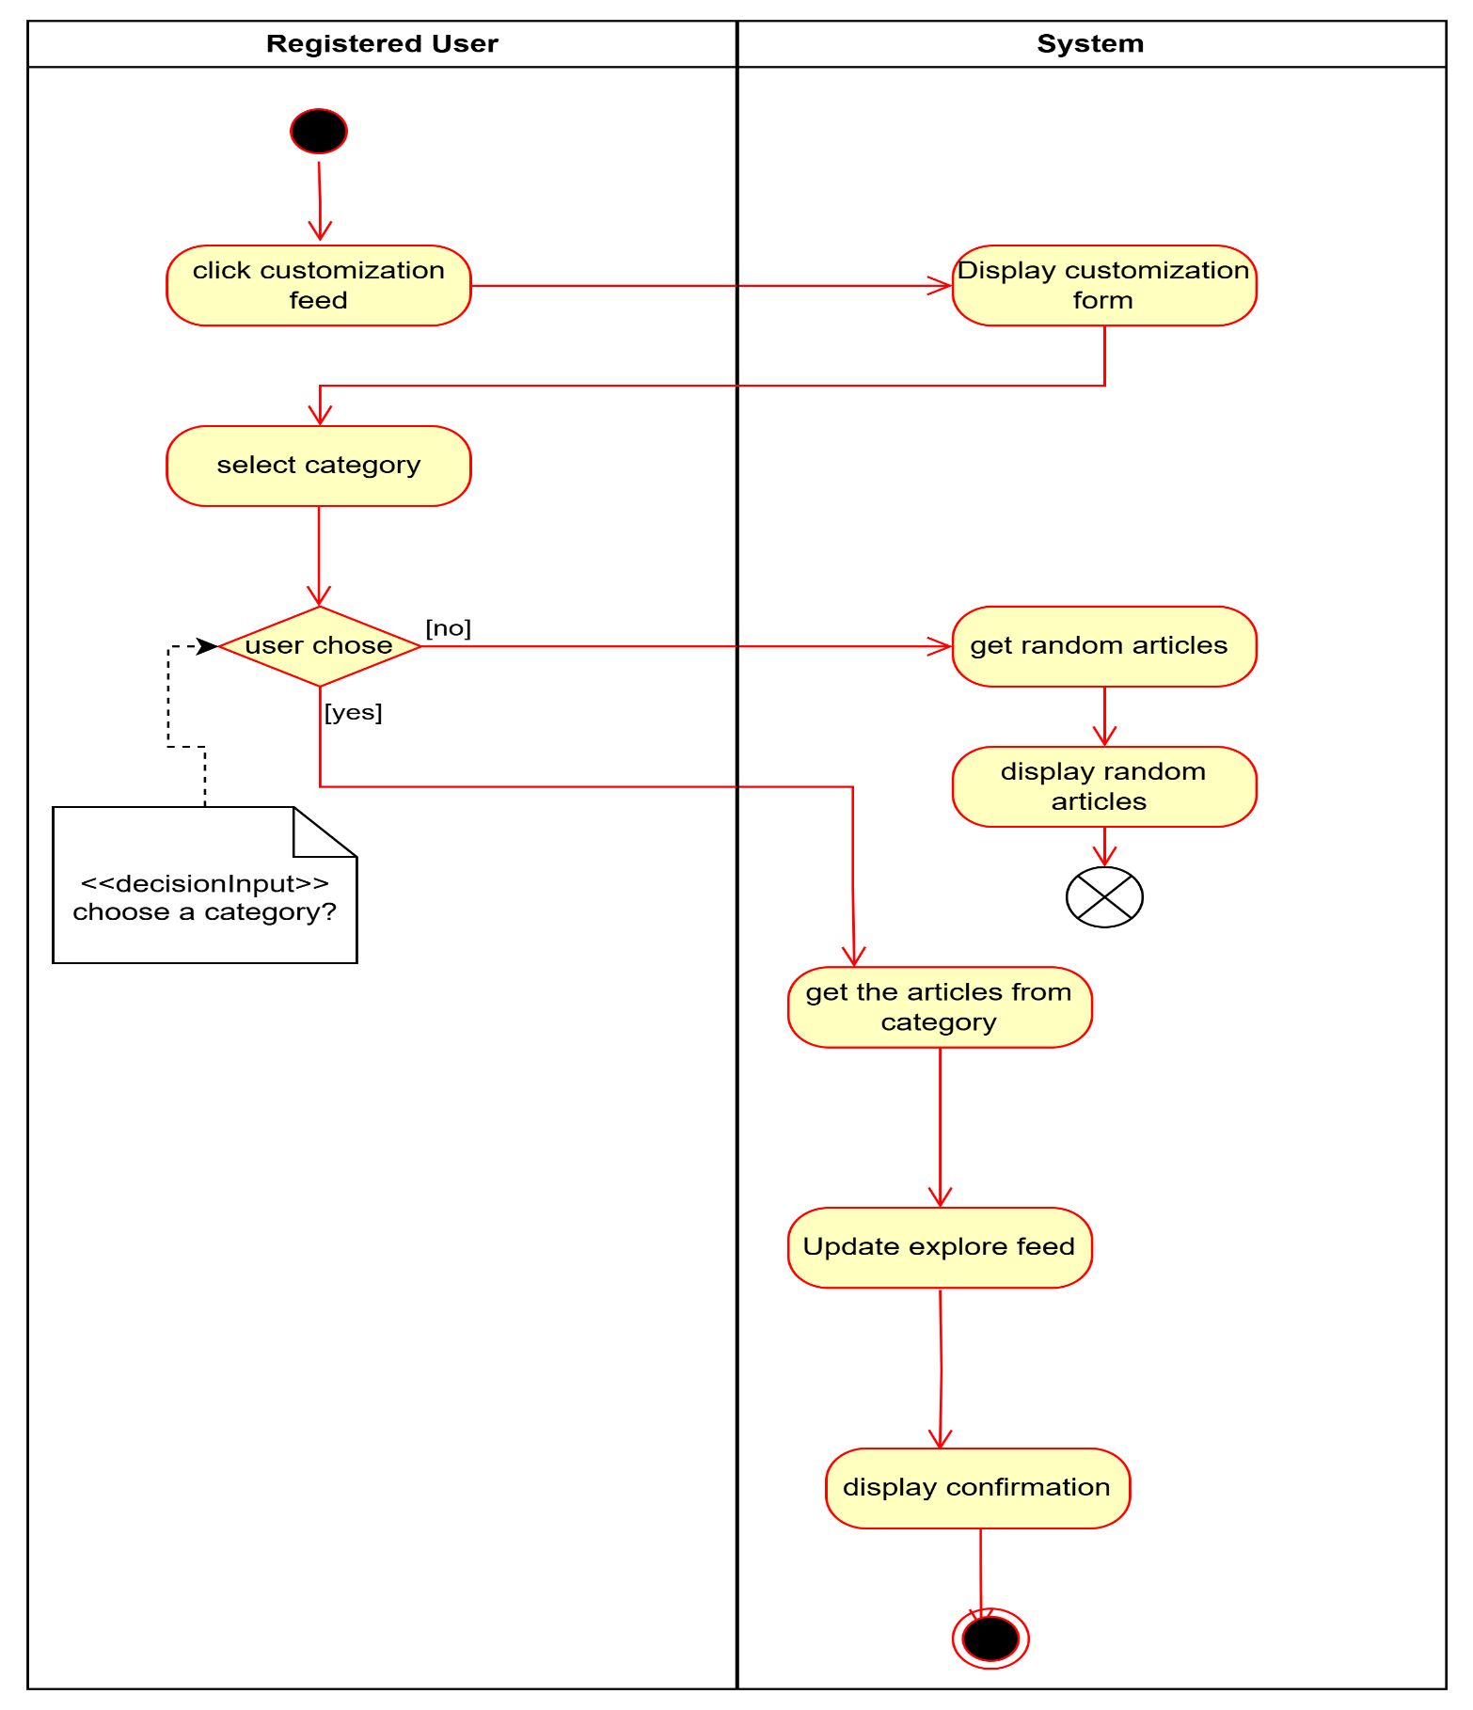

UC-11 – Report Article

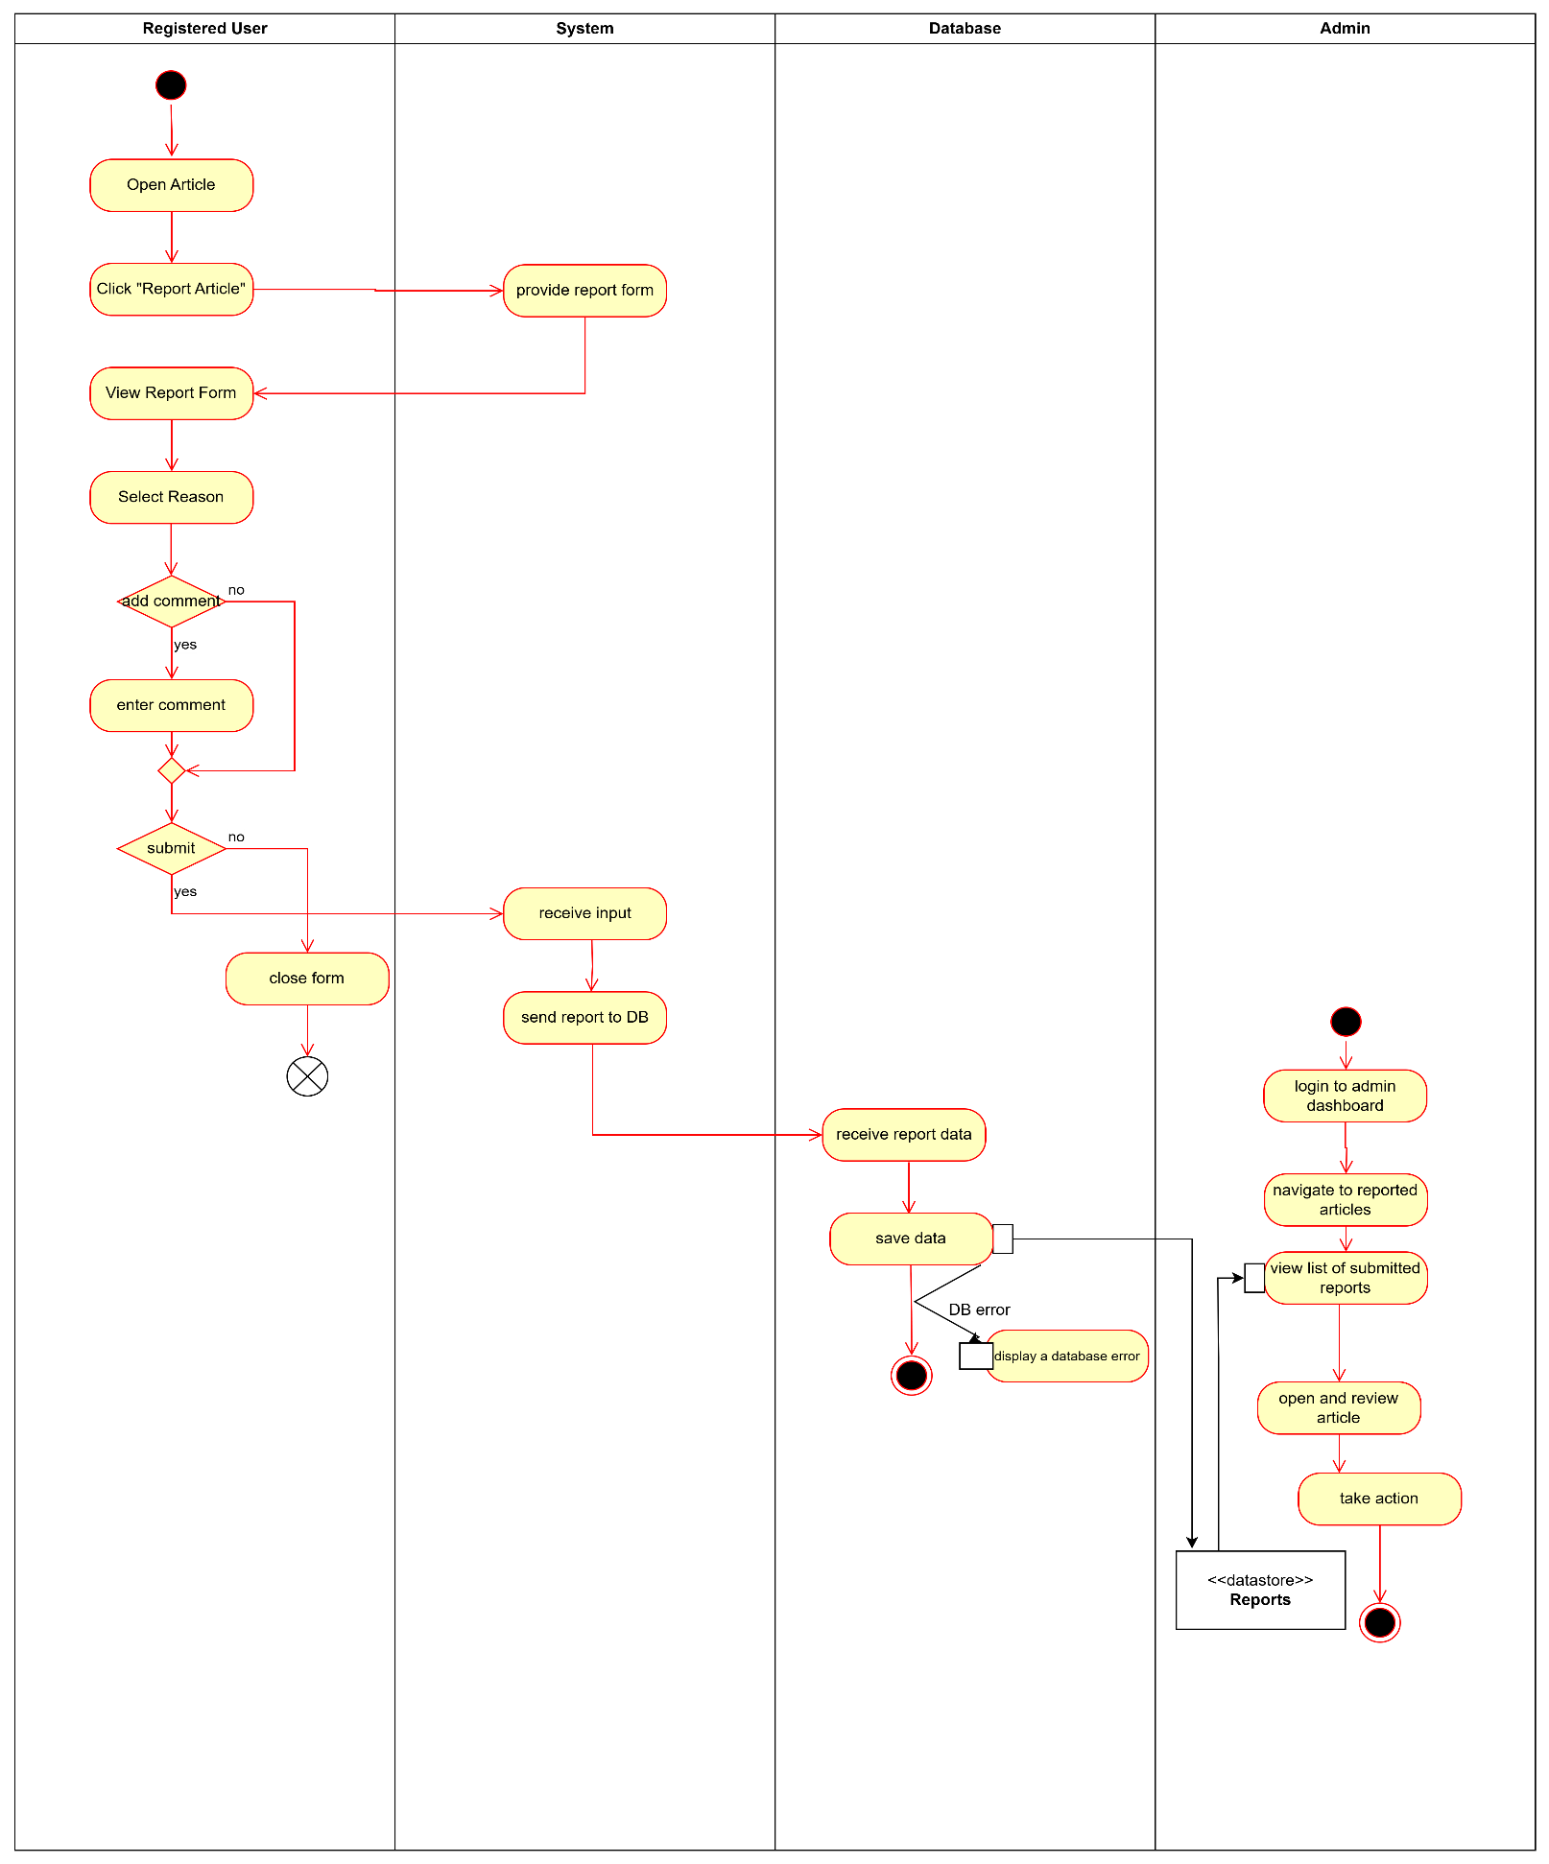

UC-12 – Manage Article

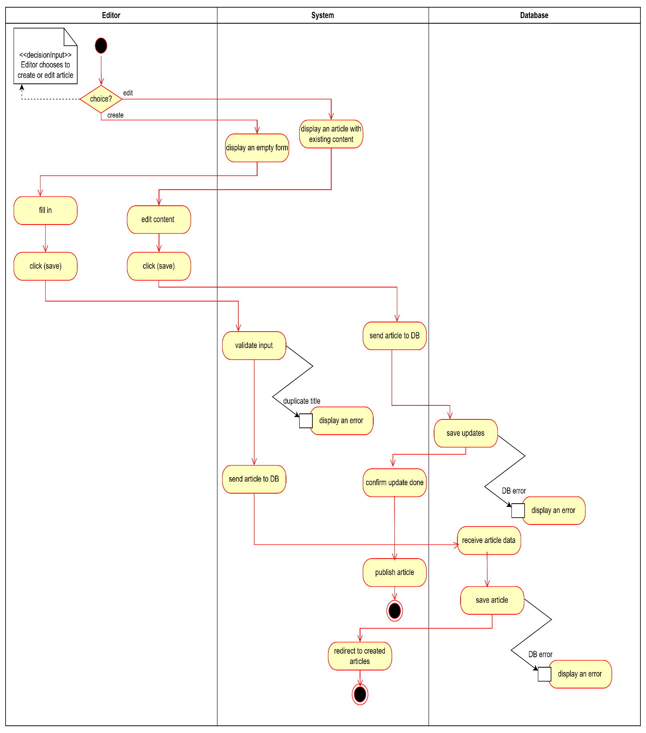

UC-13 – Manage lists

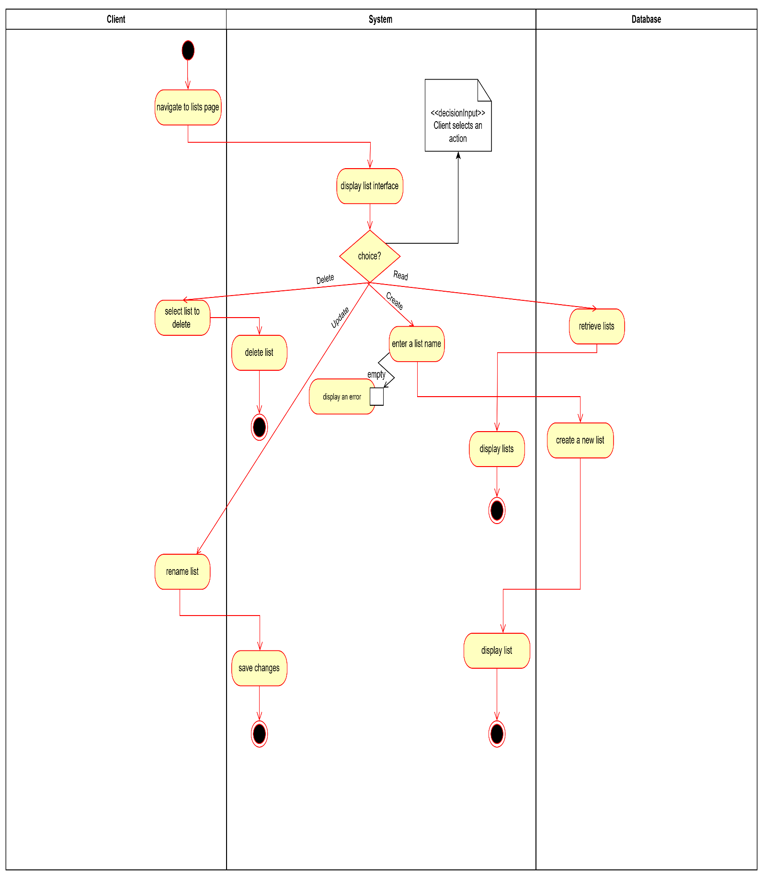

UC-19 – View Search history

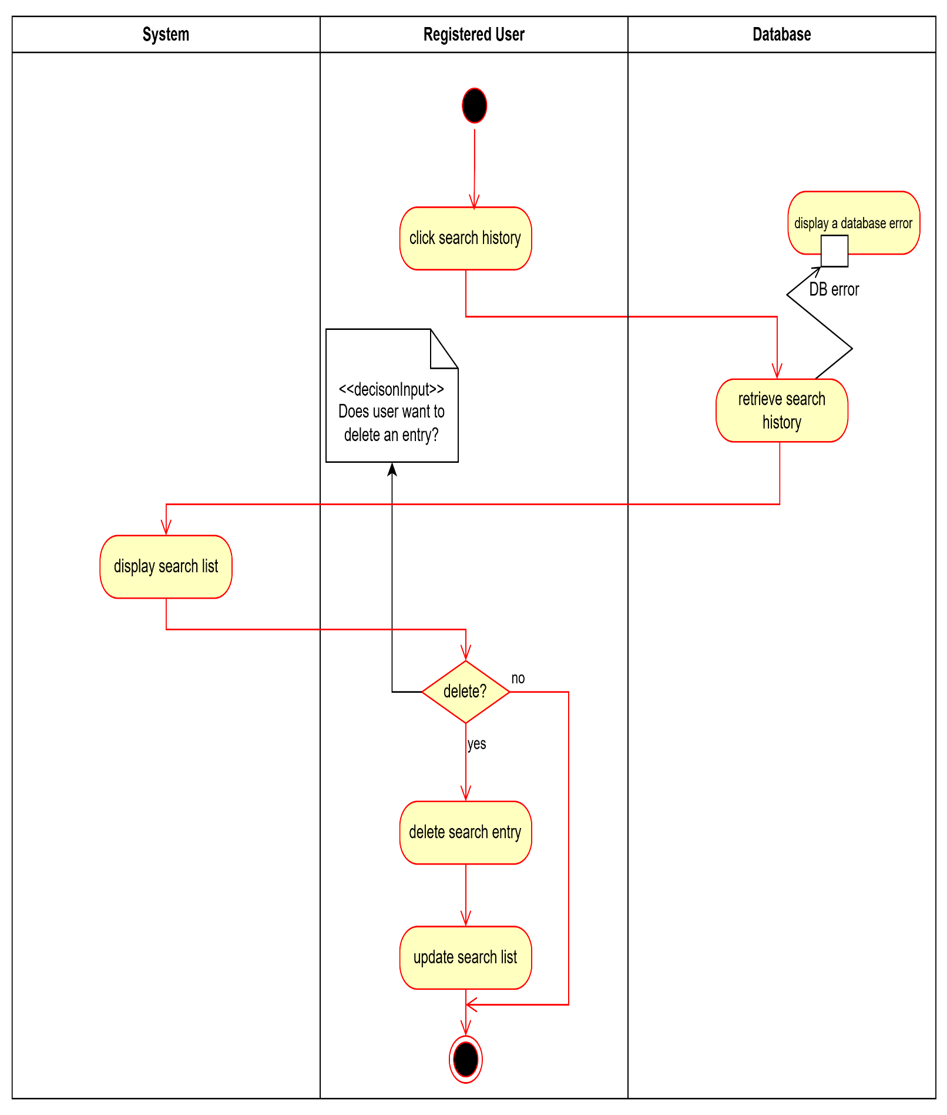

UC-22 – Manage Profile

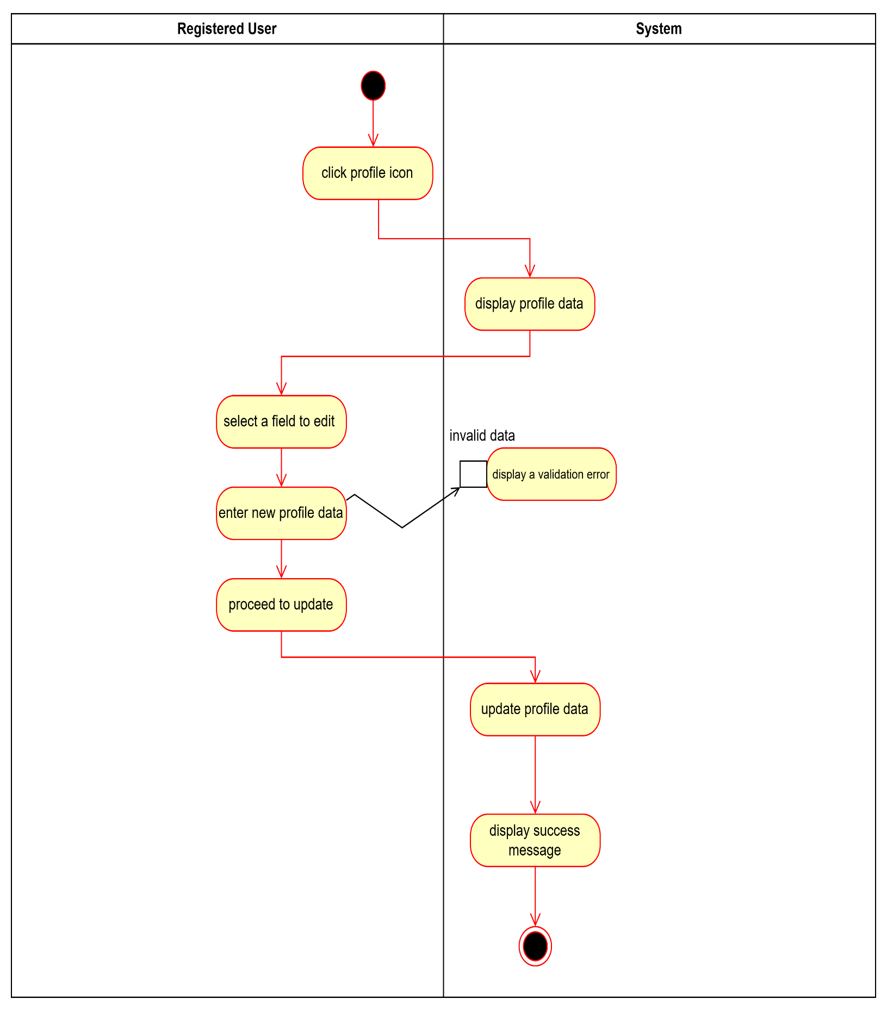**c)**

**Based on Activity Diagrams, the List of User Interfaces required for the System and the corresponding users of each interface.**

**1. Home Interface,** All users (clients, editors and admins)

**2. Search Interface,** All Users

**3. Authentication Interface,** All Users (register and login)

**4. Article Viewer Interface,** All Users

**5. Report Management Interface,** Admin

**6. Profile Management Interface,** Registered Users

**7. List Management Interface,** Registered Users

**8. Request to become an editor Interface,** Registered Users

**9. Customize Explore Feed Interface,** Editor

**10. Report Form Interface,** Registered Users

**d) Class Diagram 1**

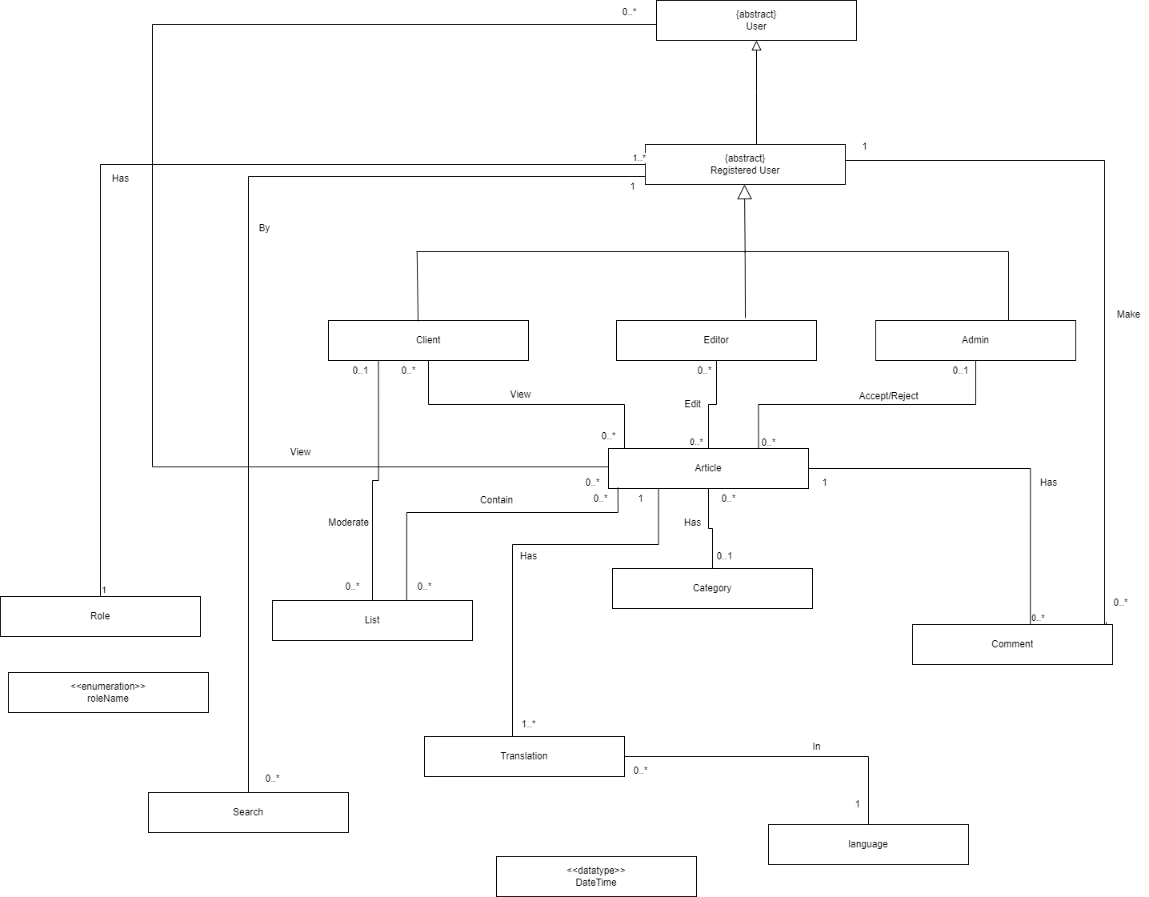

**e) Sequence diagrams**

RegisterExtension

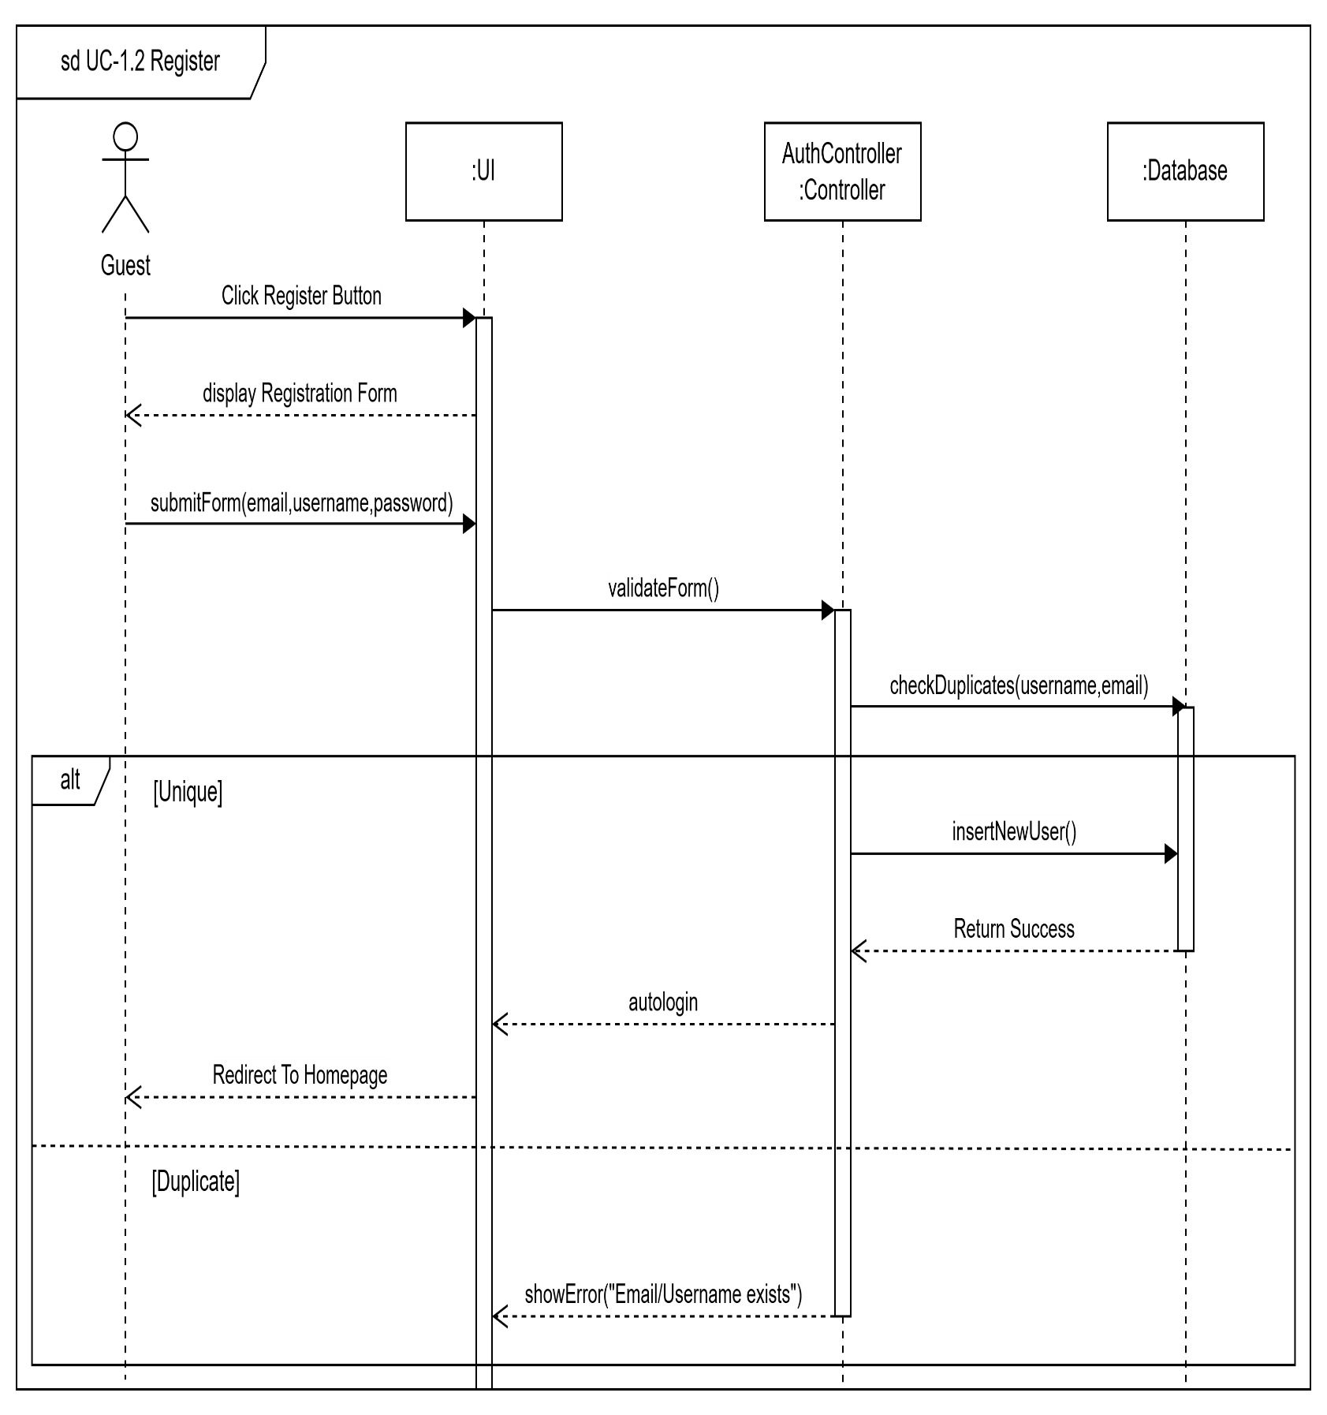

UC-3 – View Articles

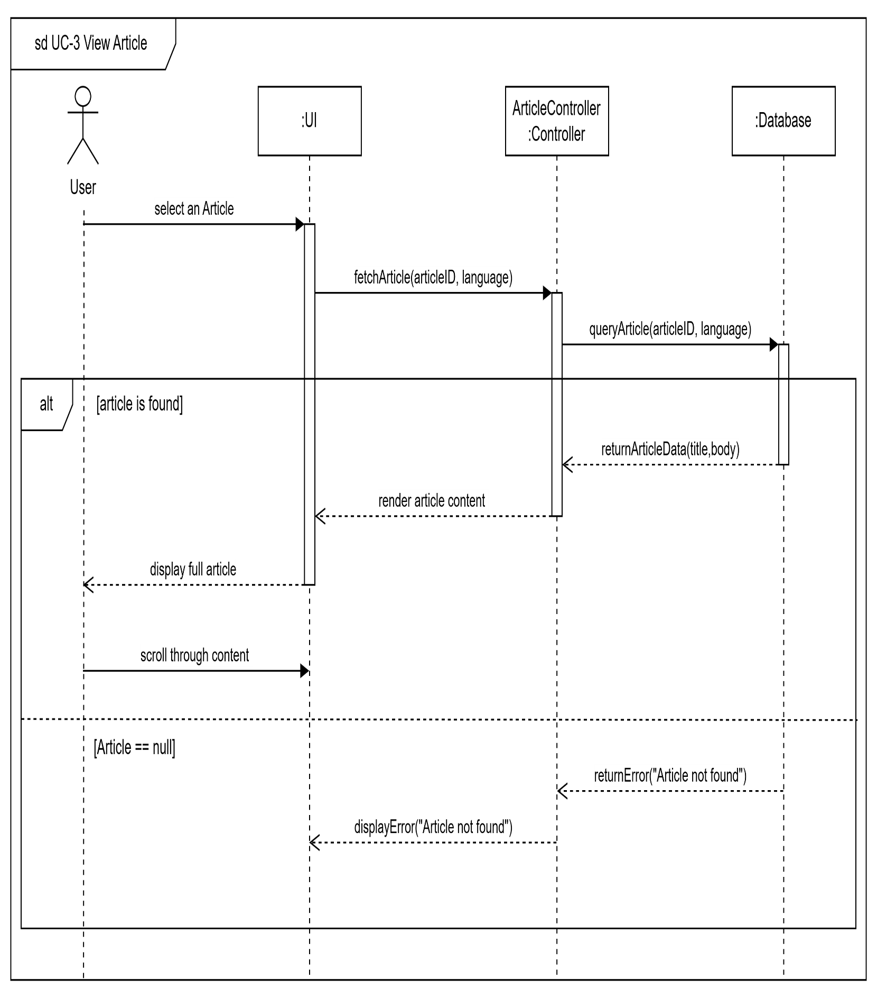

UC-4 – Customize Explore Feed

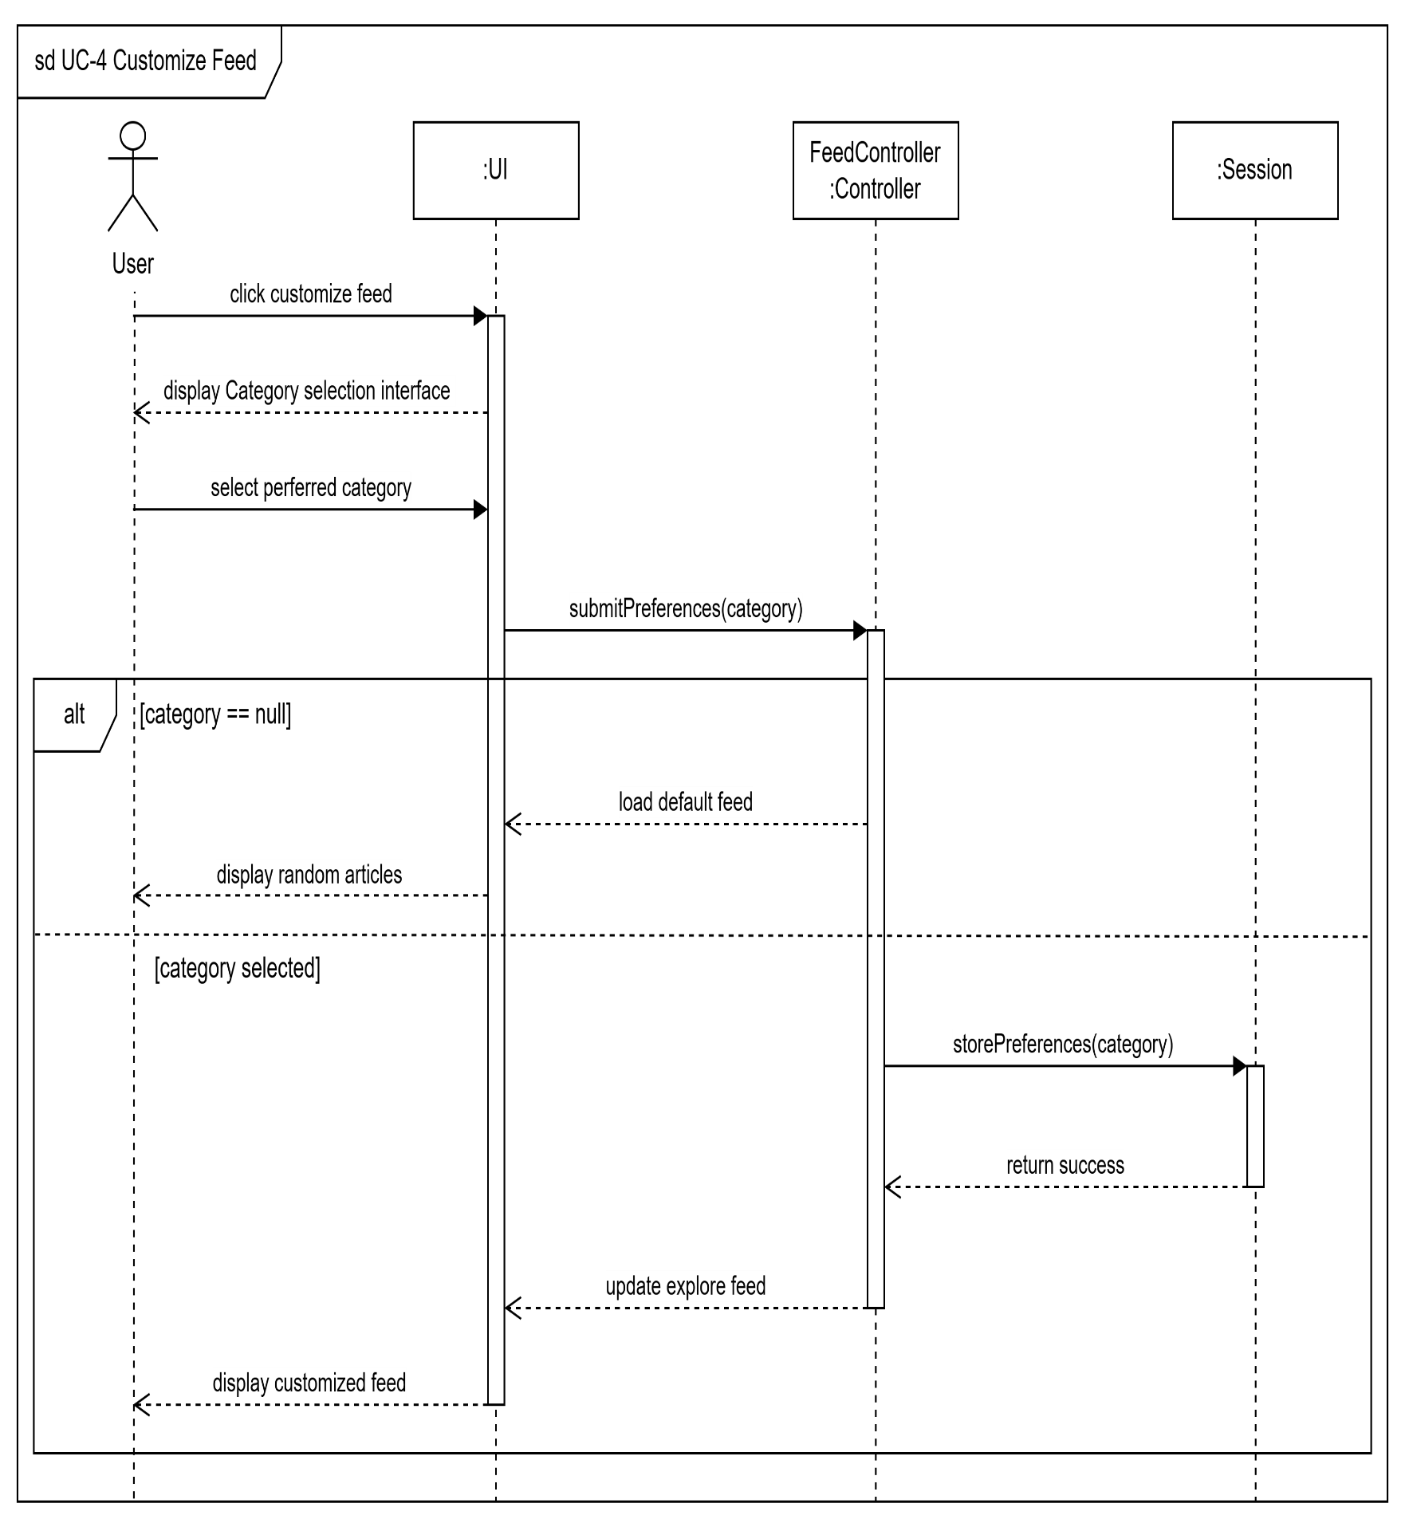

UC-5– Listen to article

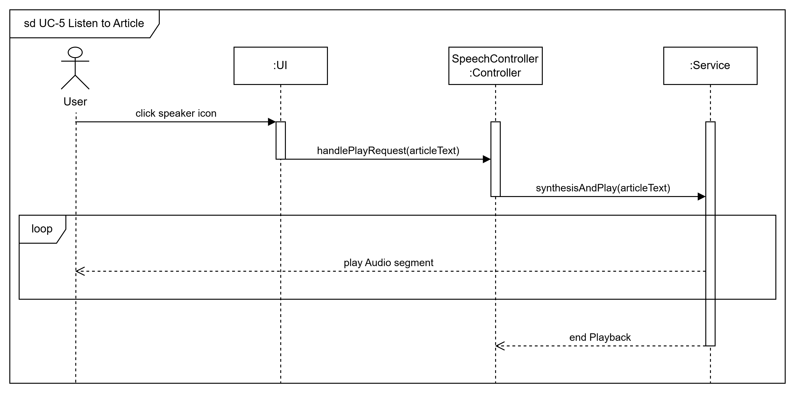

UC-6 – Translate Articles

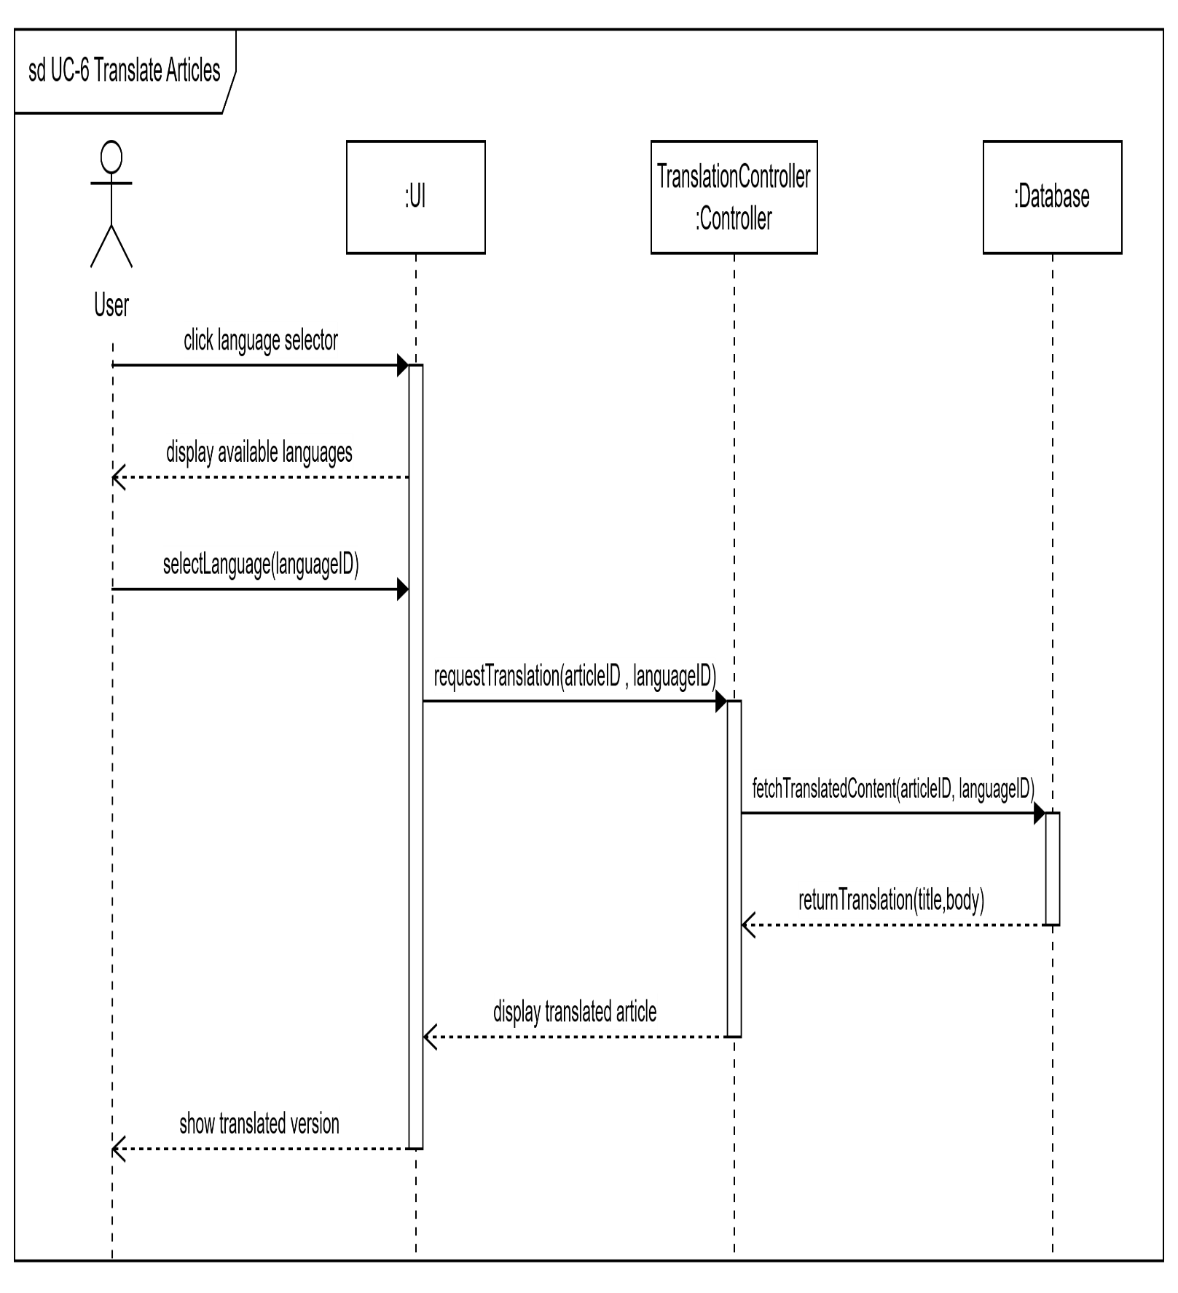

UC- 7 – Generate PDF Report

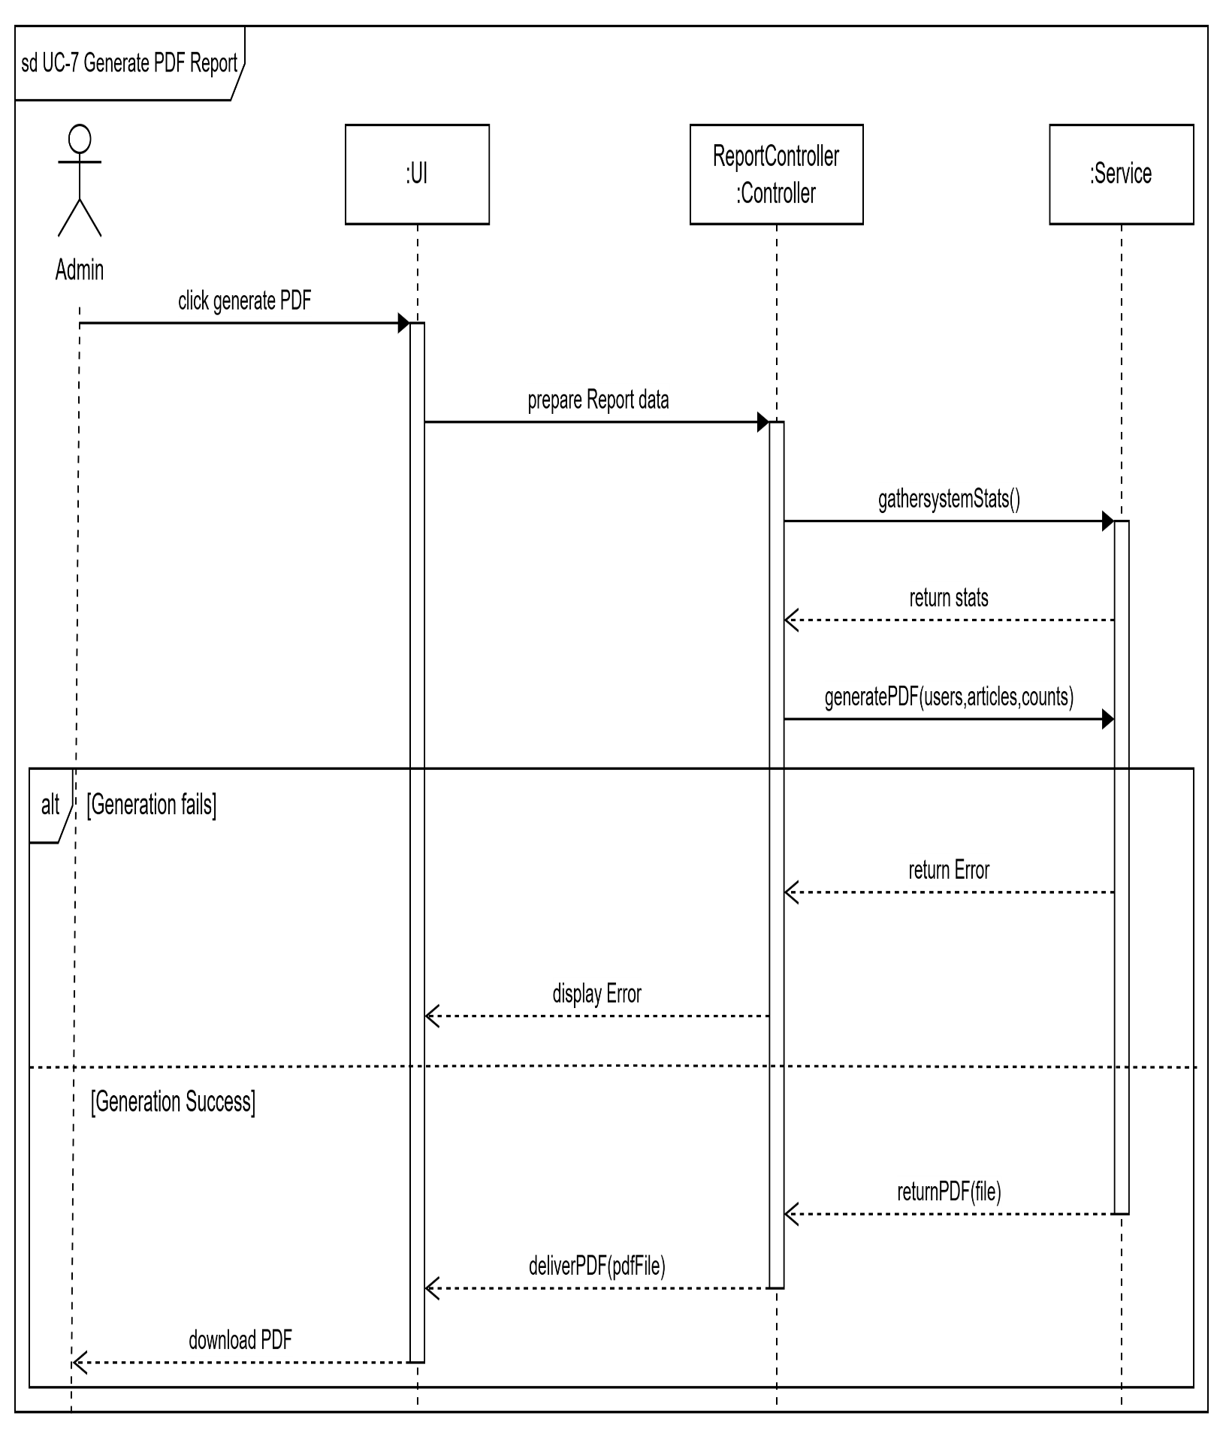

UC-8 – Interact With Articles

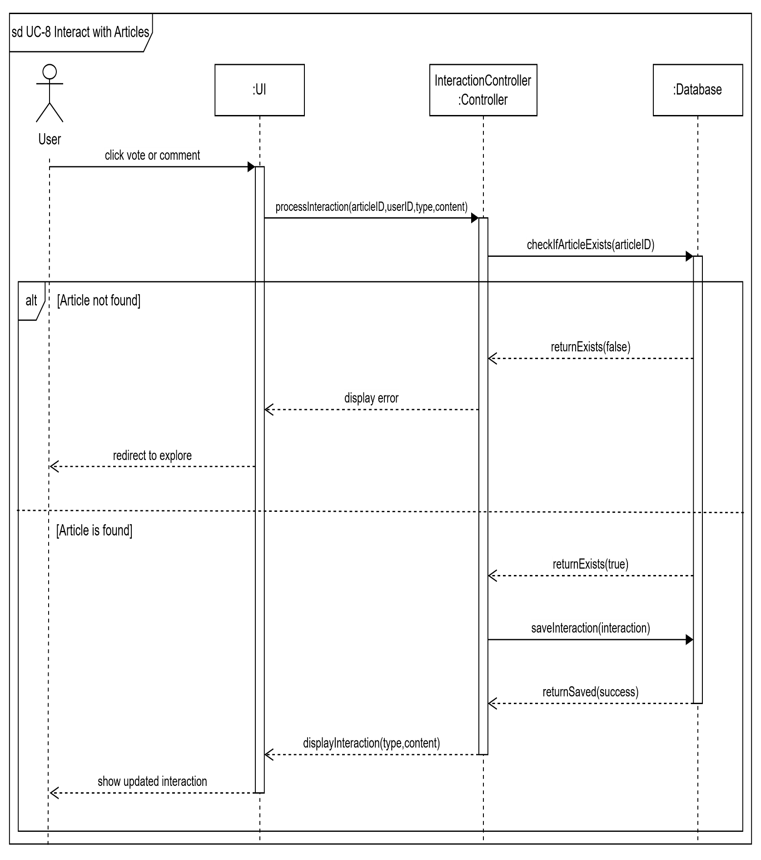

UC-9 – Bookmark Articles

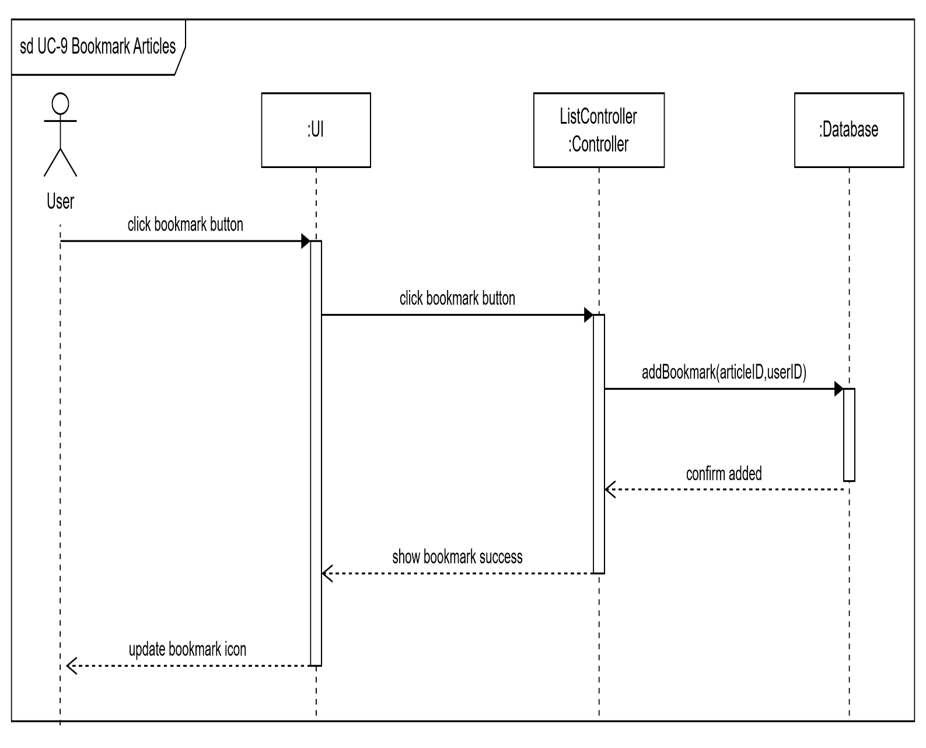

UC-10 – View Articles edit history

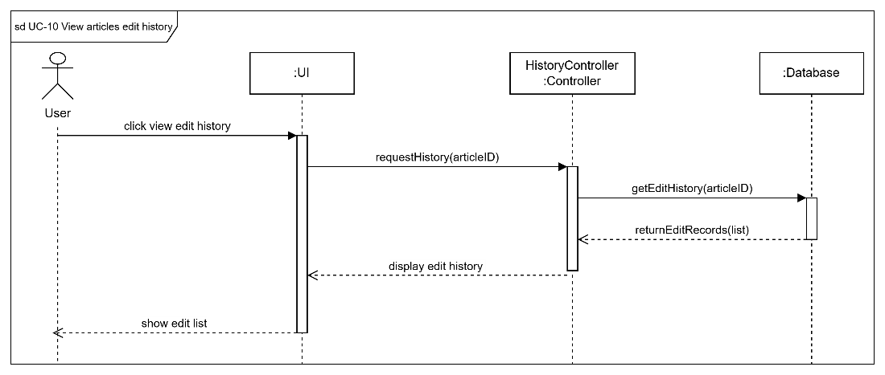

UC-11 – Report Article

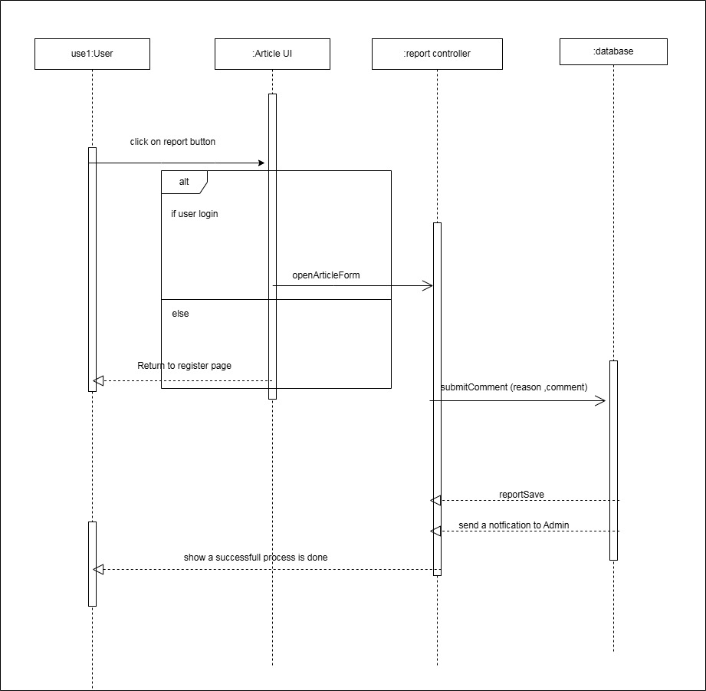

UC-13 manage list

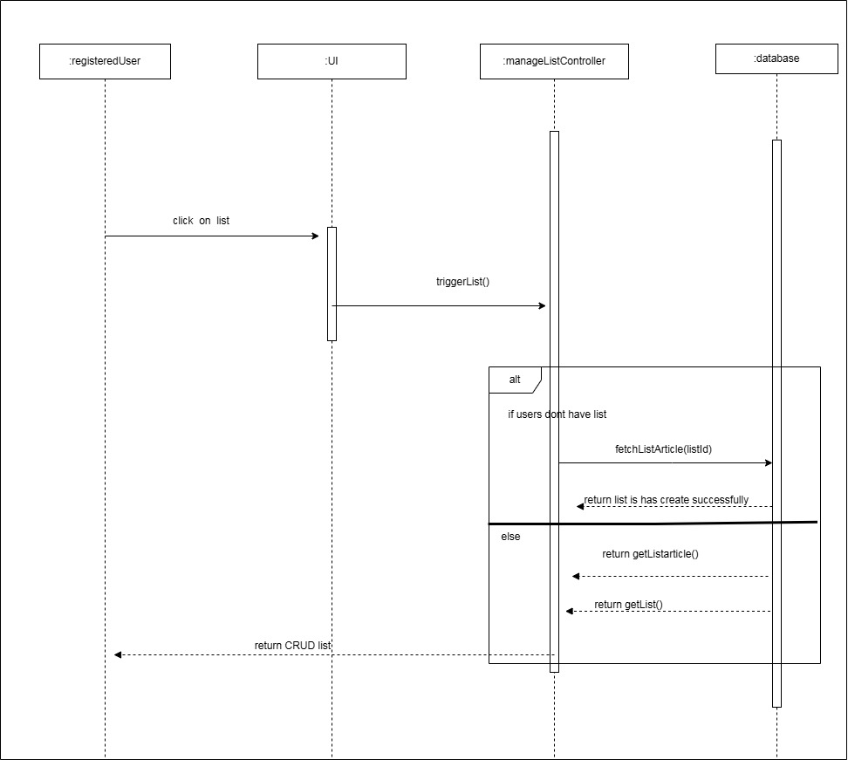

UC-14 share article on social media

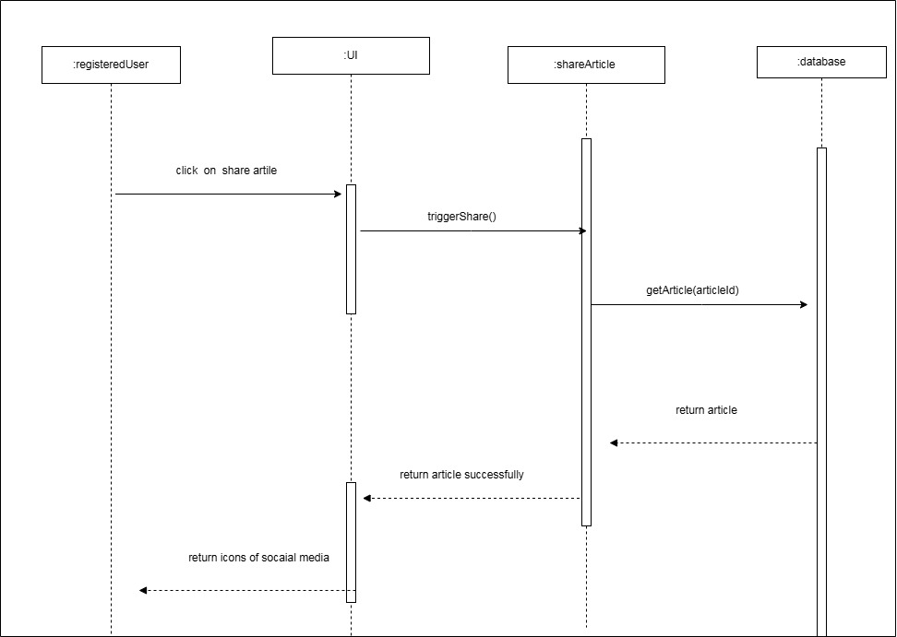

UC-15 generate AI summery

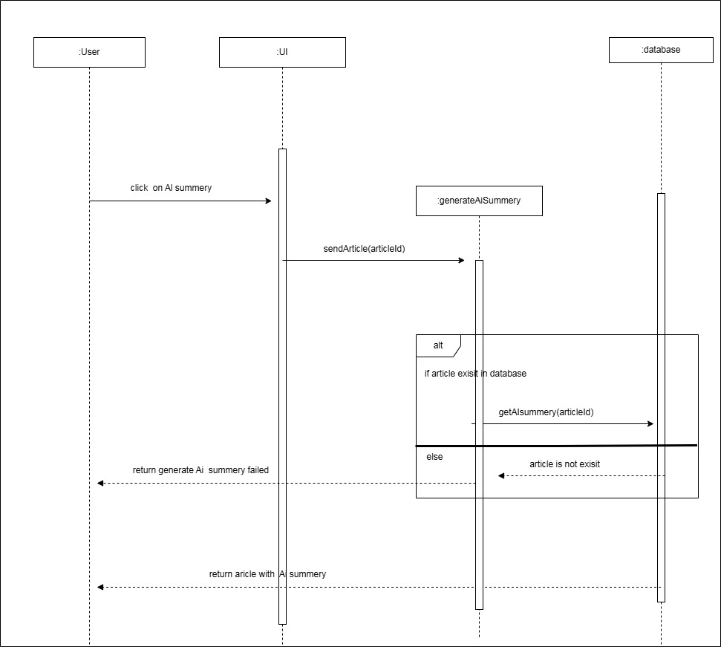

UC-16 search article

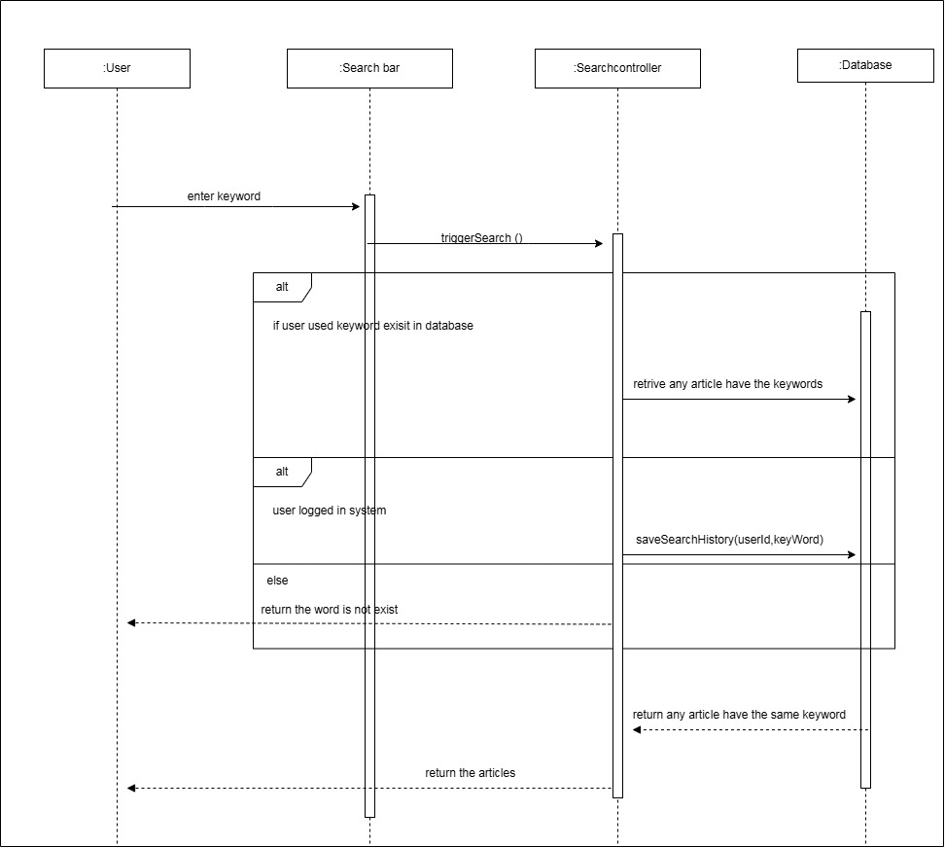

UC-17-search inside article

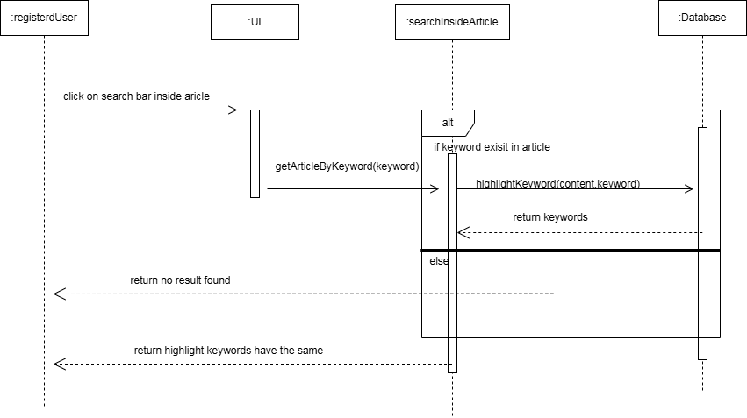

UC-18 lock an article edit

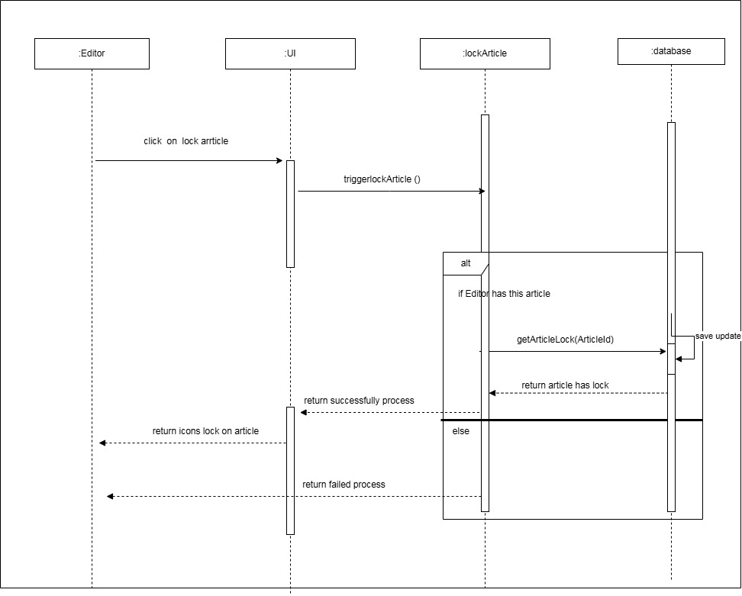

UC-19 View search history

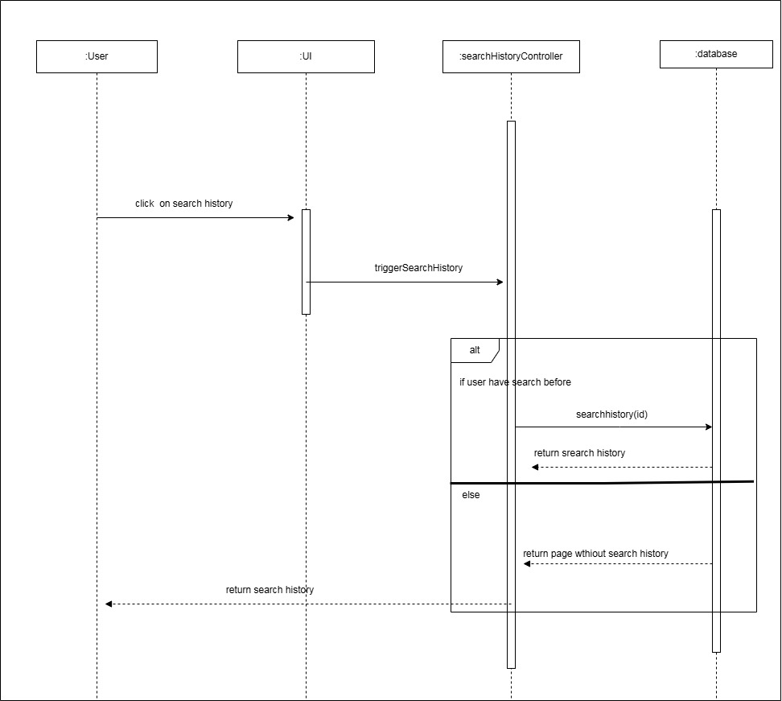

UC-20 – Remove an article

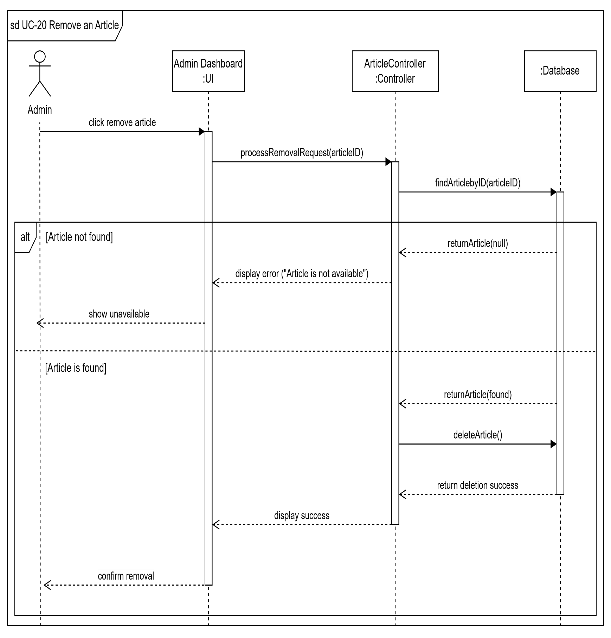

UC-21 – Browse trending section

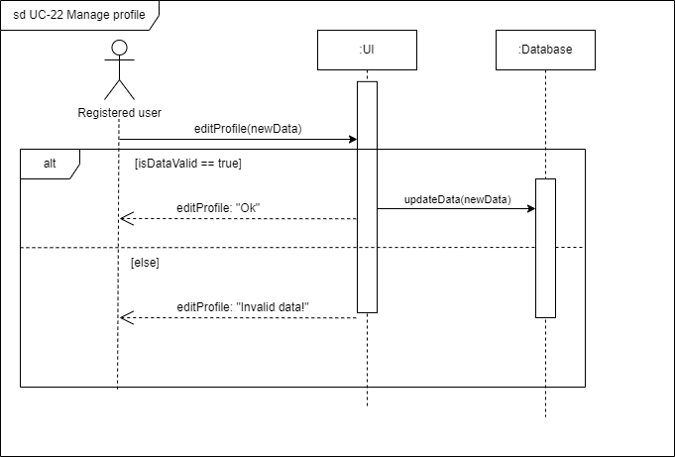

UC-22 – Manage profile



UC-23 – Manage Users

UC-24– Request to be an editor

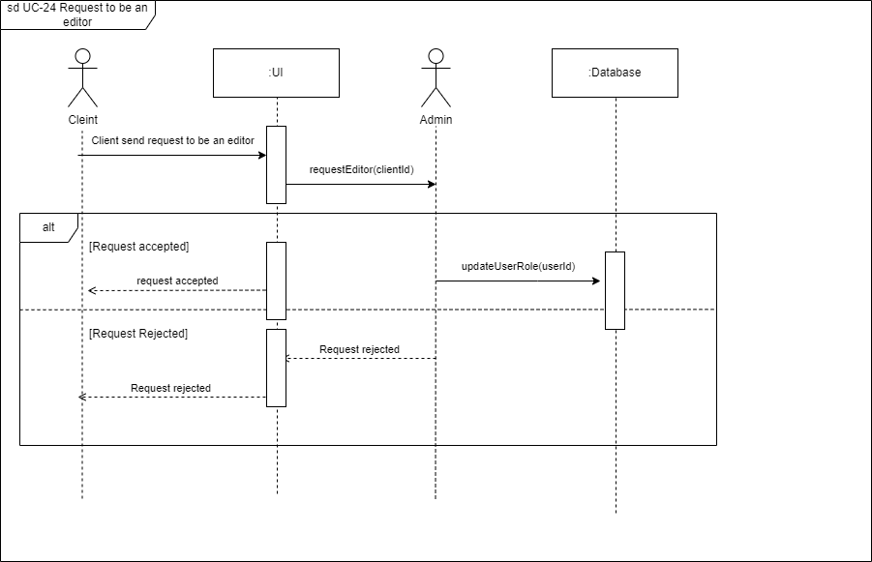

UC-25 – View profiles

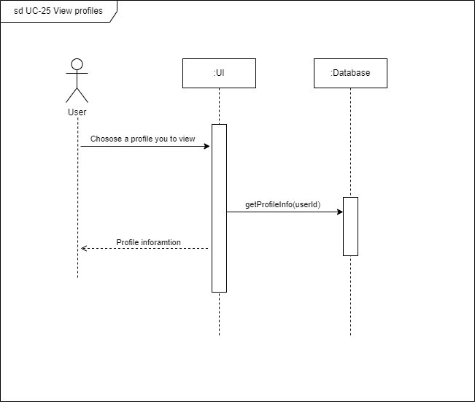

UC-26 – Generate a Random Article

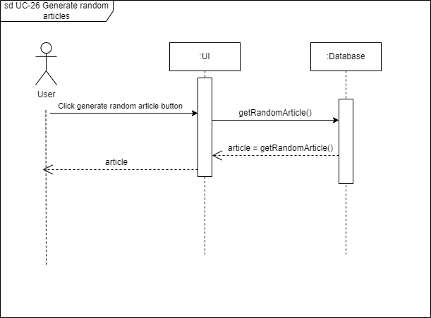

UC-27– Suggest new category

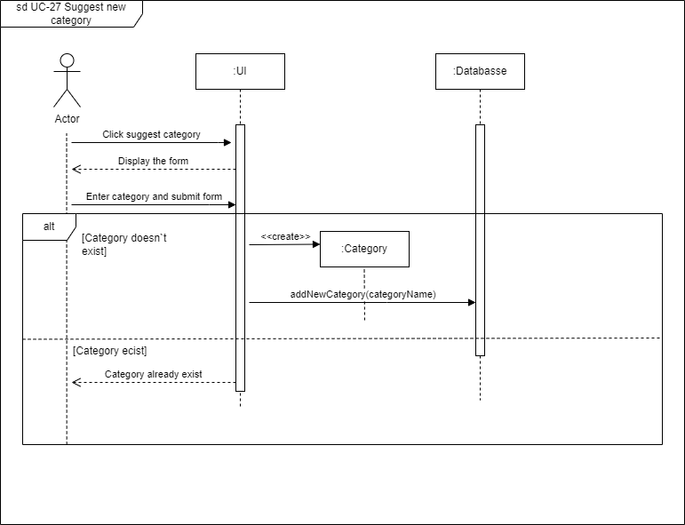

UC-28– Follow an Editor

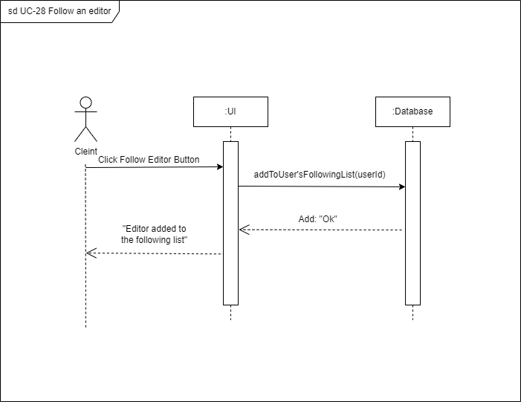

UC-29–View editor`s leaderboard

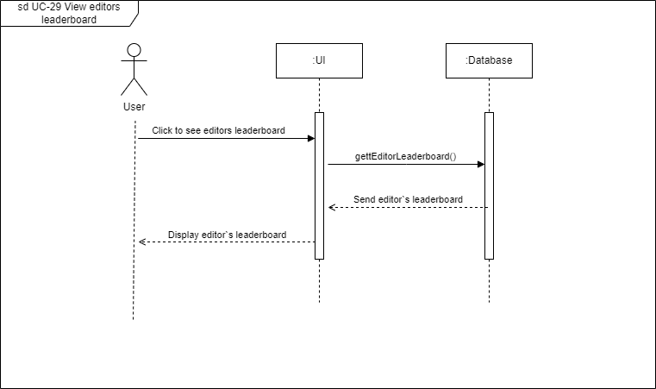

UC-30– Moderate Interaction

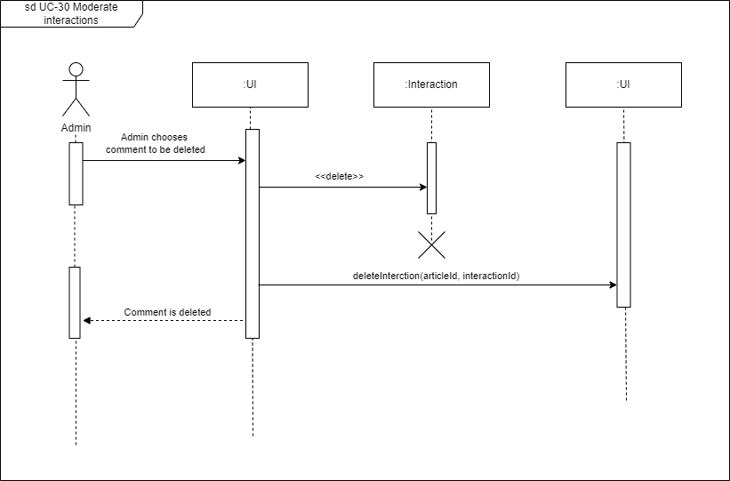

**f) System Sequence Diagrams (SSDs)**

**UC-1.2 Register**

**UC-4 – Customize Explore Feed**

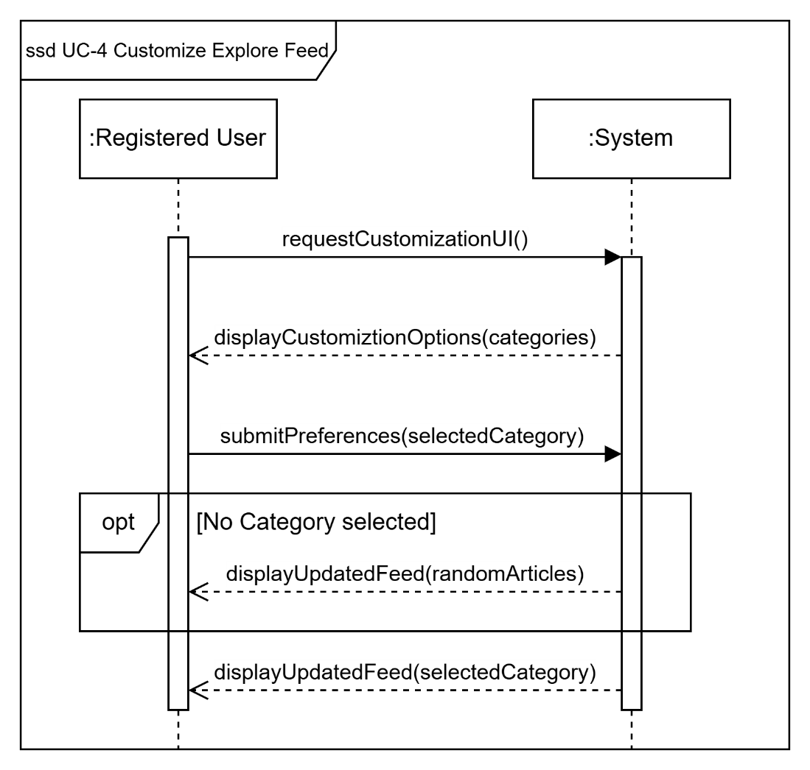

**UC-11 Report Article**

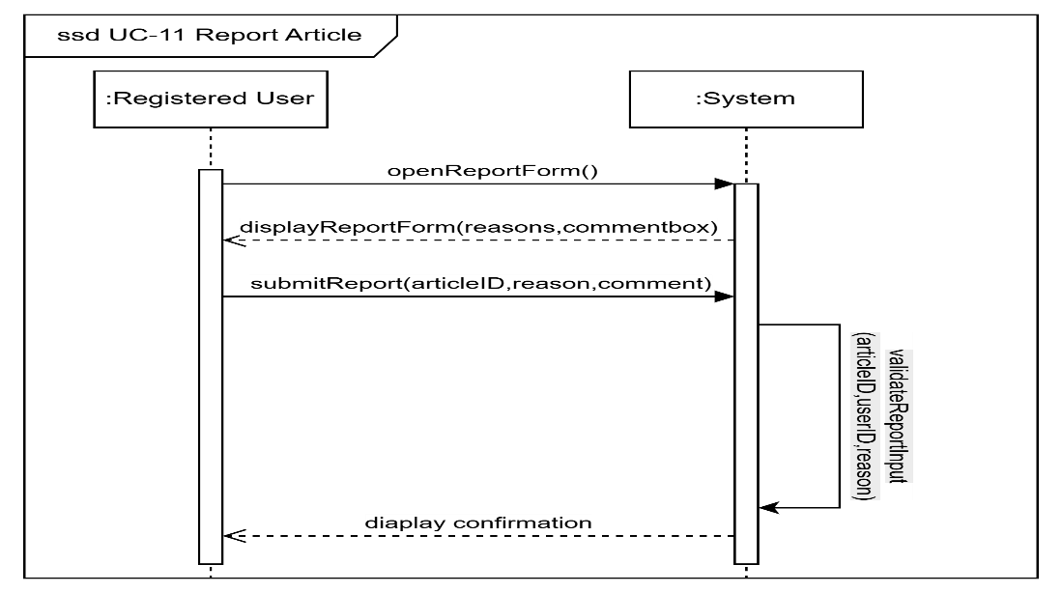

**UC-13 Manage Lists**

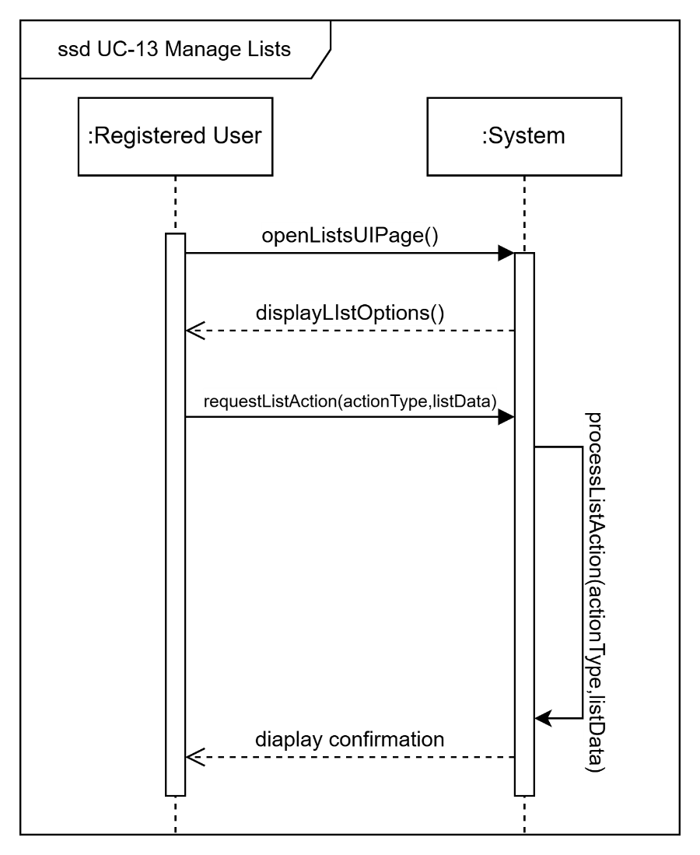

**UC-22 Manage Profile**

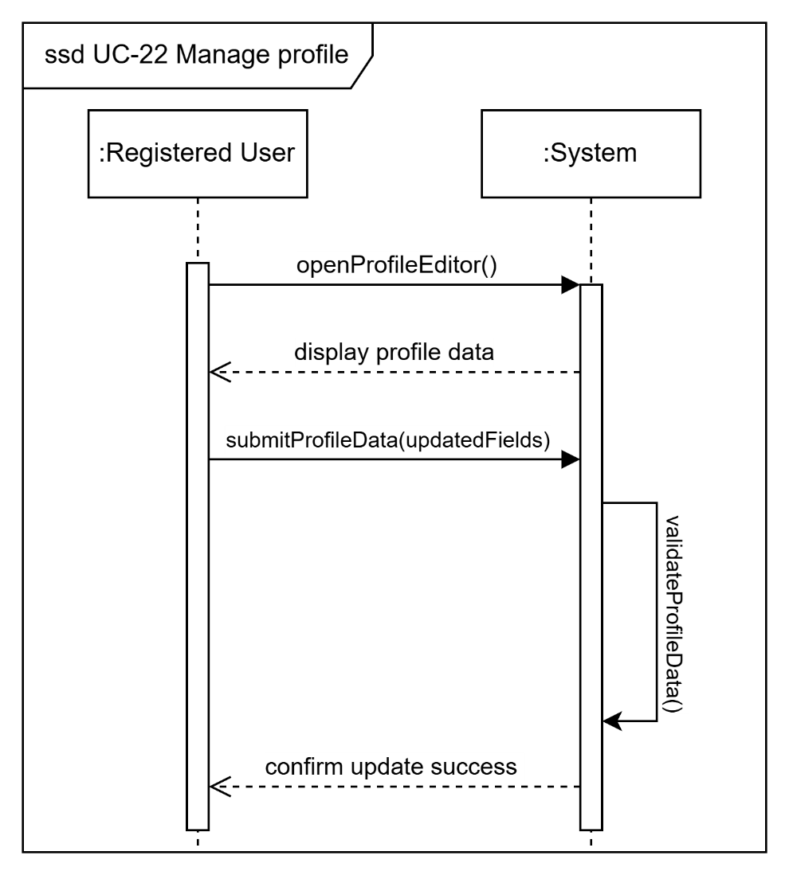

**UC-23 – Manage Users**

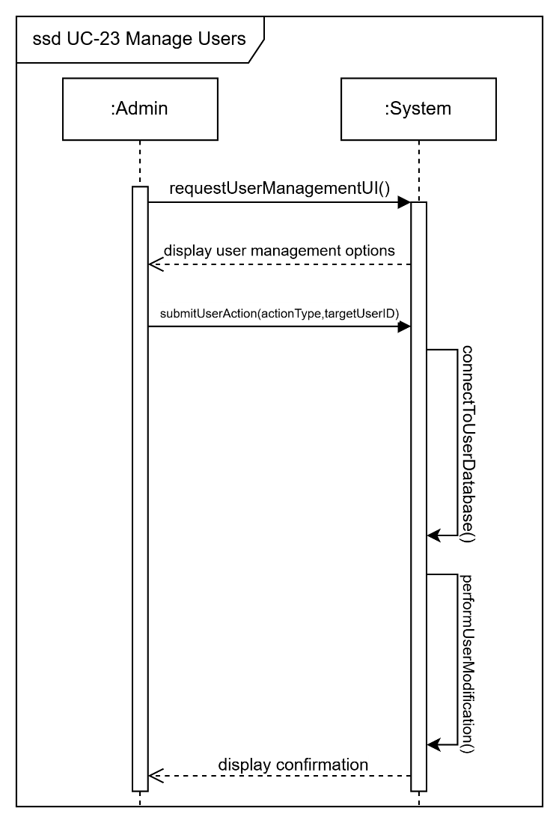

**g) Collaboration/Communication Diagram**

**1)**

**2)**

**3)**

**4)**

**5)**

**6)**

**h) Strategies used to implement the use cases**

* **Document analysis:** looking at how Wikipedia manages multilingual content.
* **Use cases/User stories:** helped us to understand and identify needed features.
* **Brainstorming sessions:** by exchanging information between our team members.
* **Observation:** watch how users currently do tasks and see how people use existing online encyclopedias or translation tools.
* **AI services:** some AI services that helped us gather some information.

**i) Class Diagram 2**

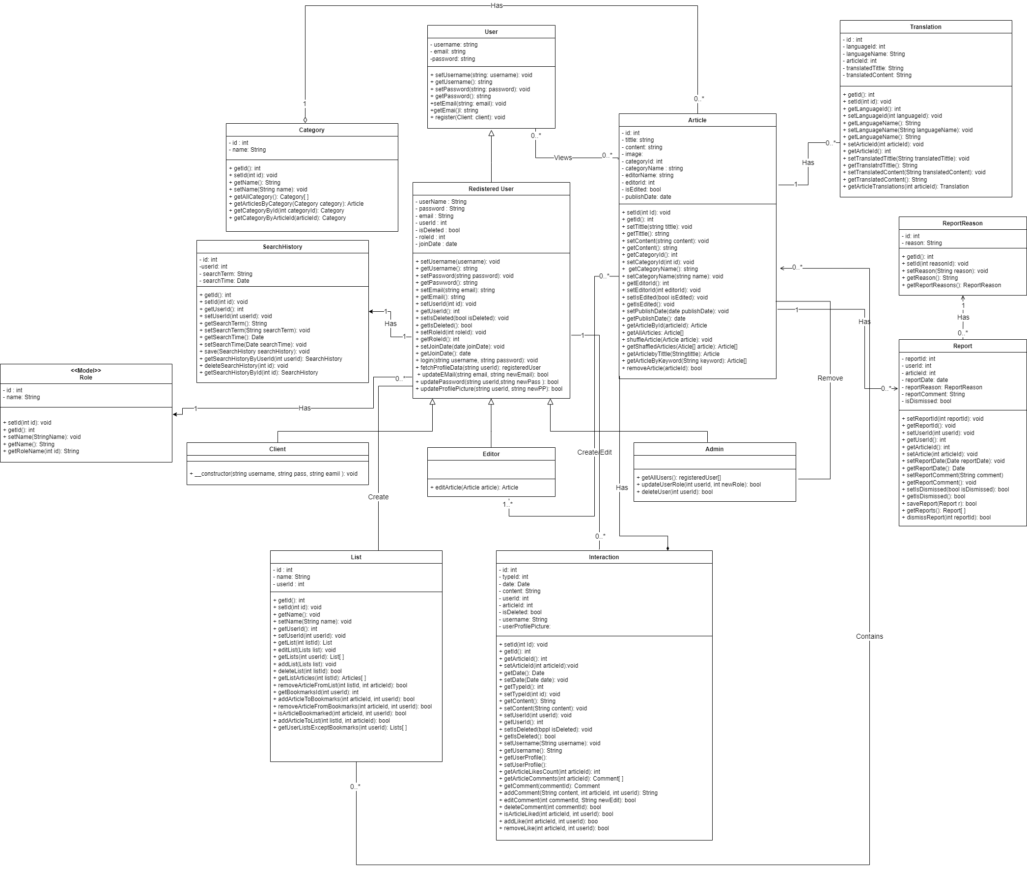

**j) Three Design Patterns**

1- Singleton

2- Publisher Subscriber

1. Abstraction

**k) Class 3**

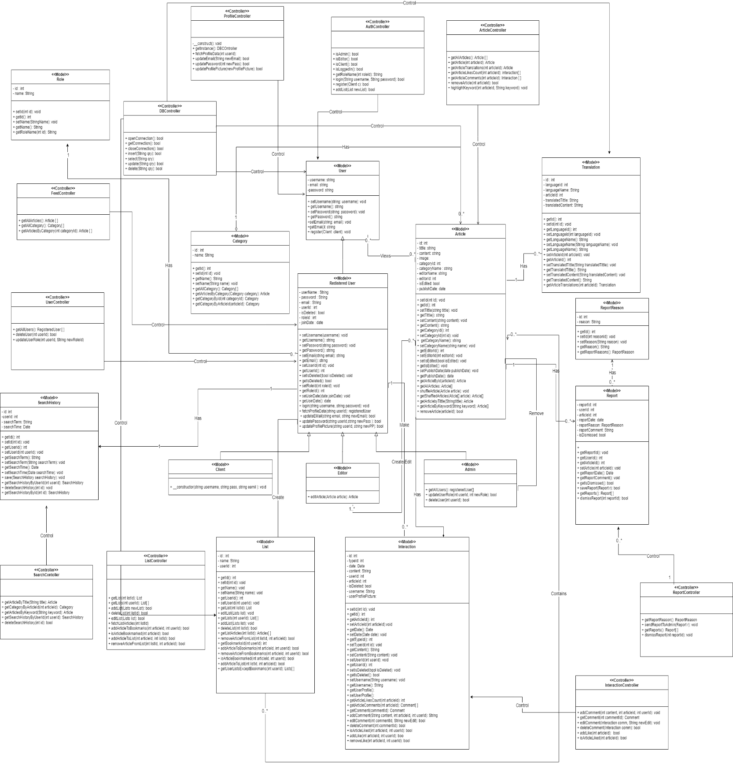

**l) BONUS: A Design smell in our design and how it can be avoided**

**m) BONUS: Class Structuring Criteria**

**n) What did we rely on in interaction diagrams (Collaboration Diagram), forks or cascades?**

Cascades

**o) Package Diagram for Classes**

**1)**

**2)**

**3)**

**4)**

**5)**

**6)**

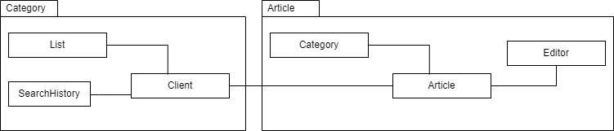

**p) Object Diagrams**

**UC-9 – Bookmark Articles (PRECONDITIONS)**

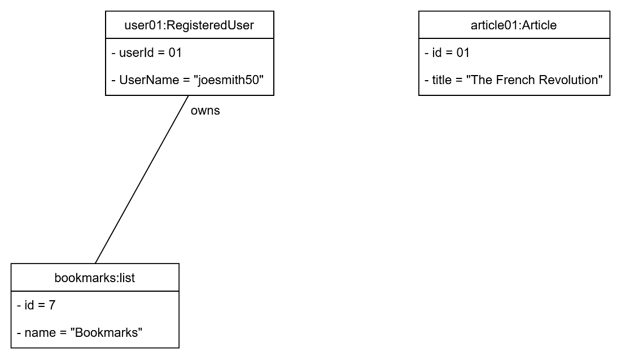

**UC-9 – Bookmark Articles (POSTCONDITIONS)**

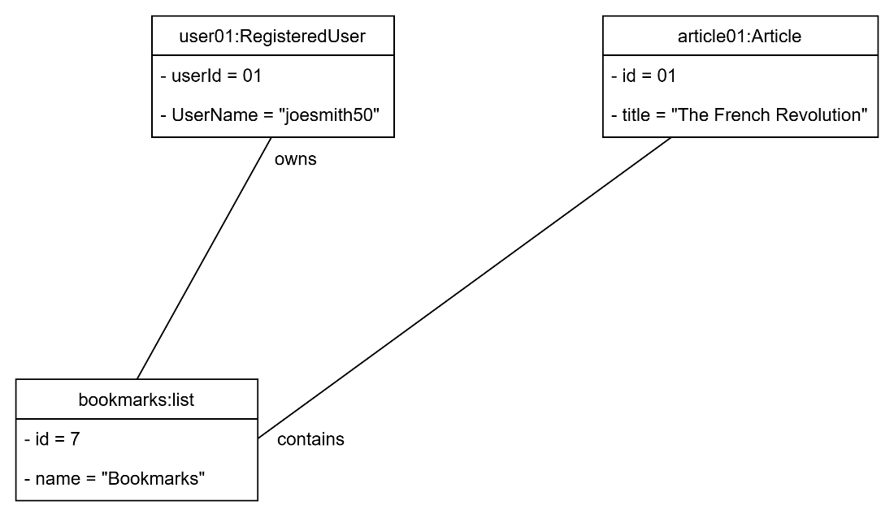

**UC-11 – Report Articles (PRECONDITIONS)**

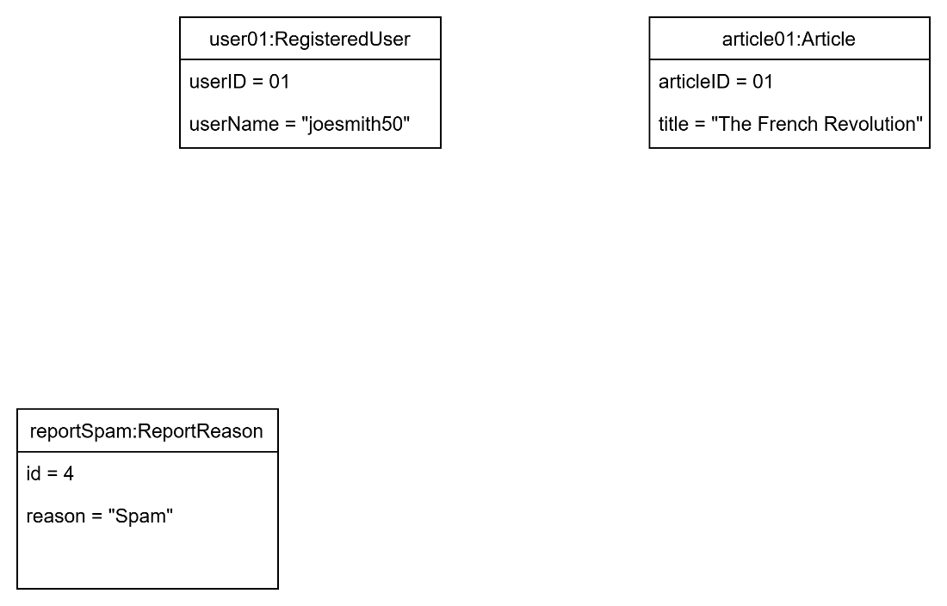

**UC-11 – Report Articles (POSTCONDITIONS)**

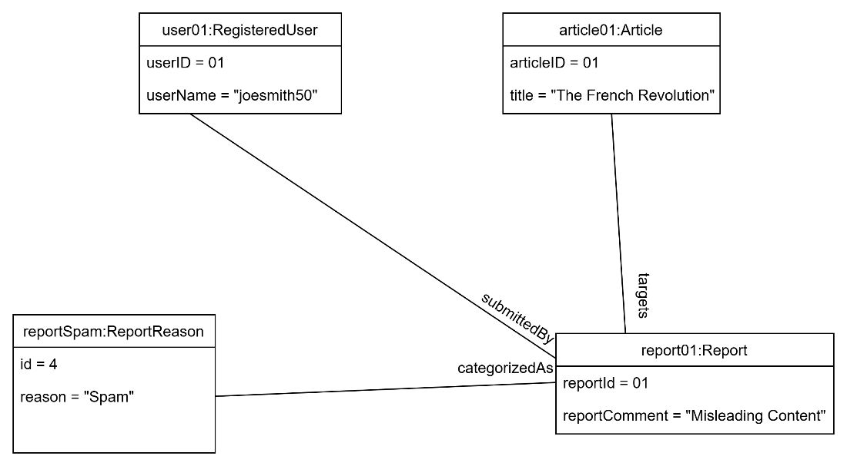

**UC-13 – Manage [edit] Lists (PRECONDITIONS)**

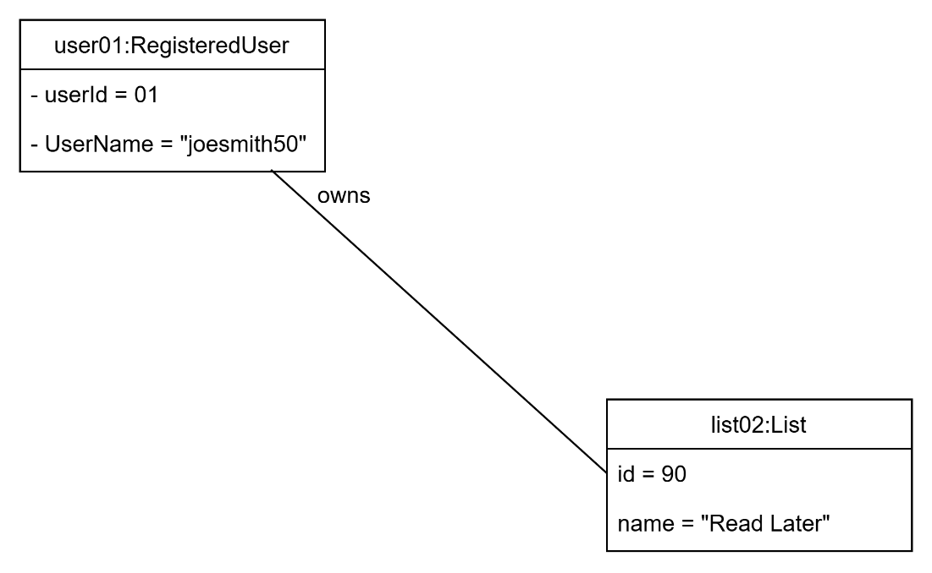

**UC-13 – Manage [edit] Lists (POSTCONDITIONS)**

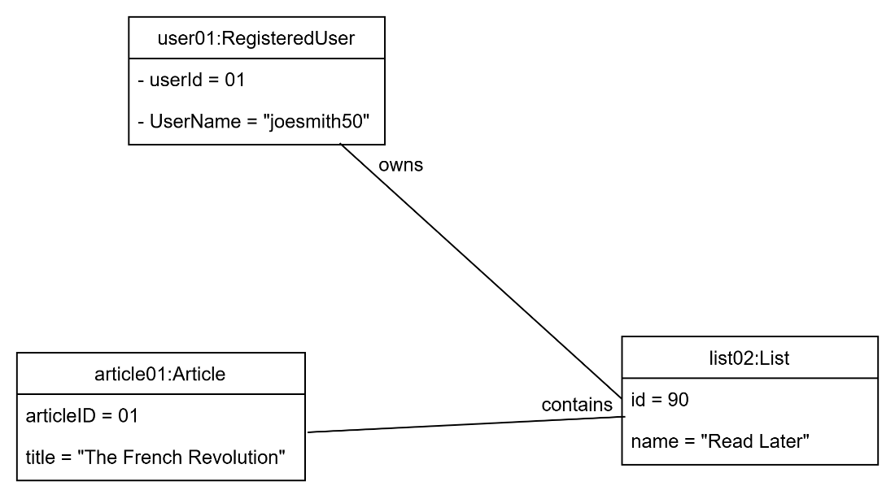

**UC-14-view search history (PRECONDITIONS)**

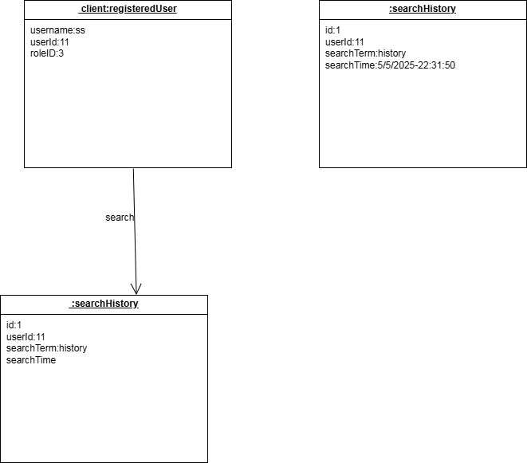

**UC-14-view search history (POSTCONDITION)**

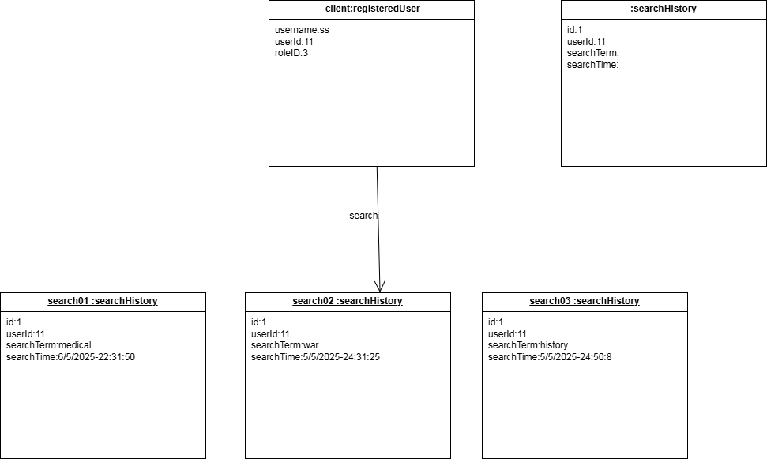

**UC-22 – Manage Profile (PRECONDITIONS)**

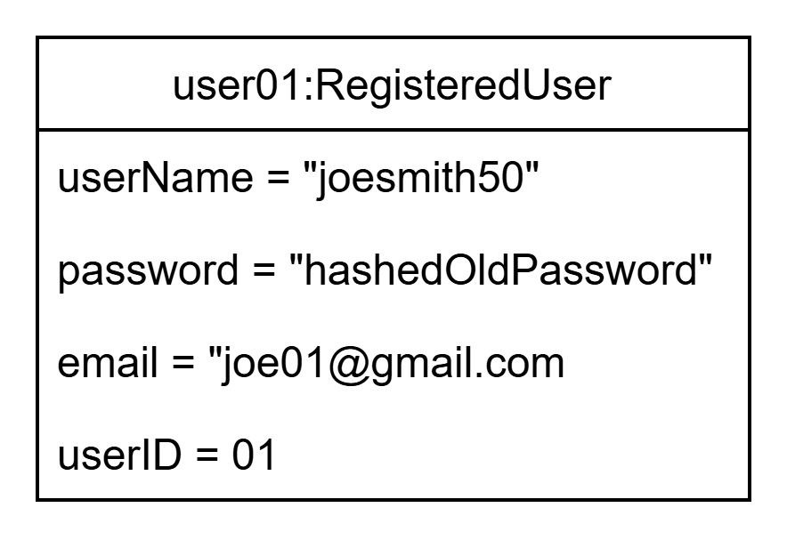

**UC-22 – Manage Profile (POSTCONDITIONS)**

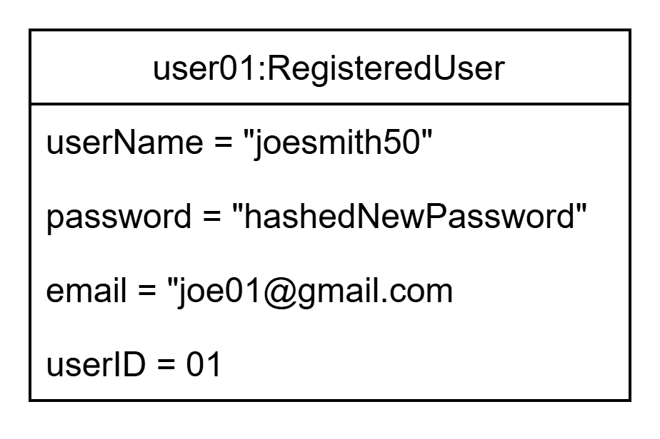

**UC-23 – Manage Users (PRECONDITIONS)**

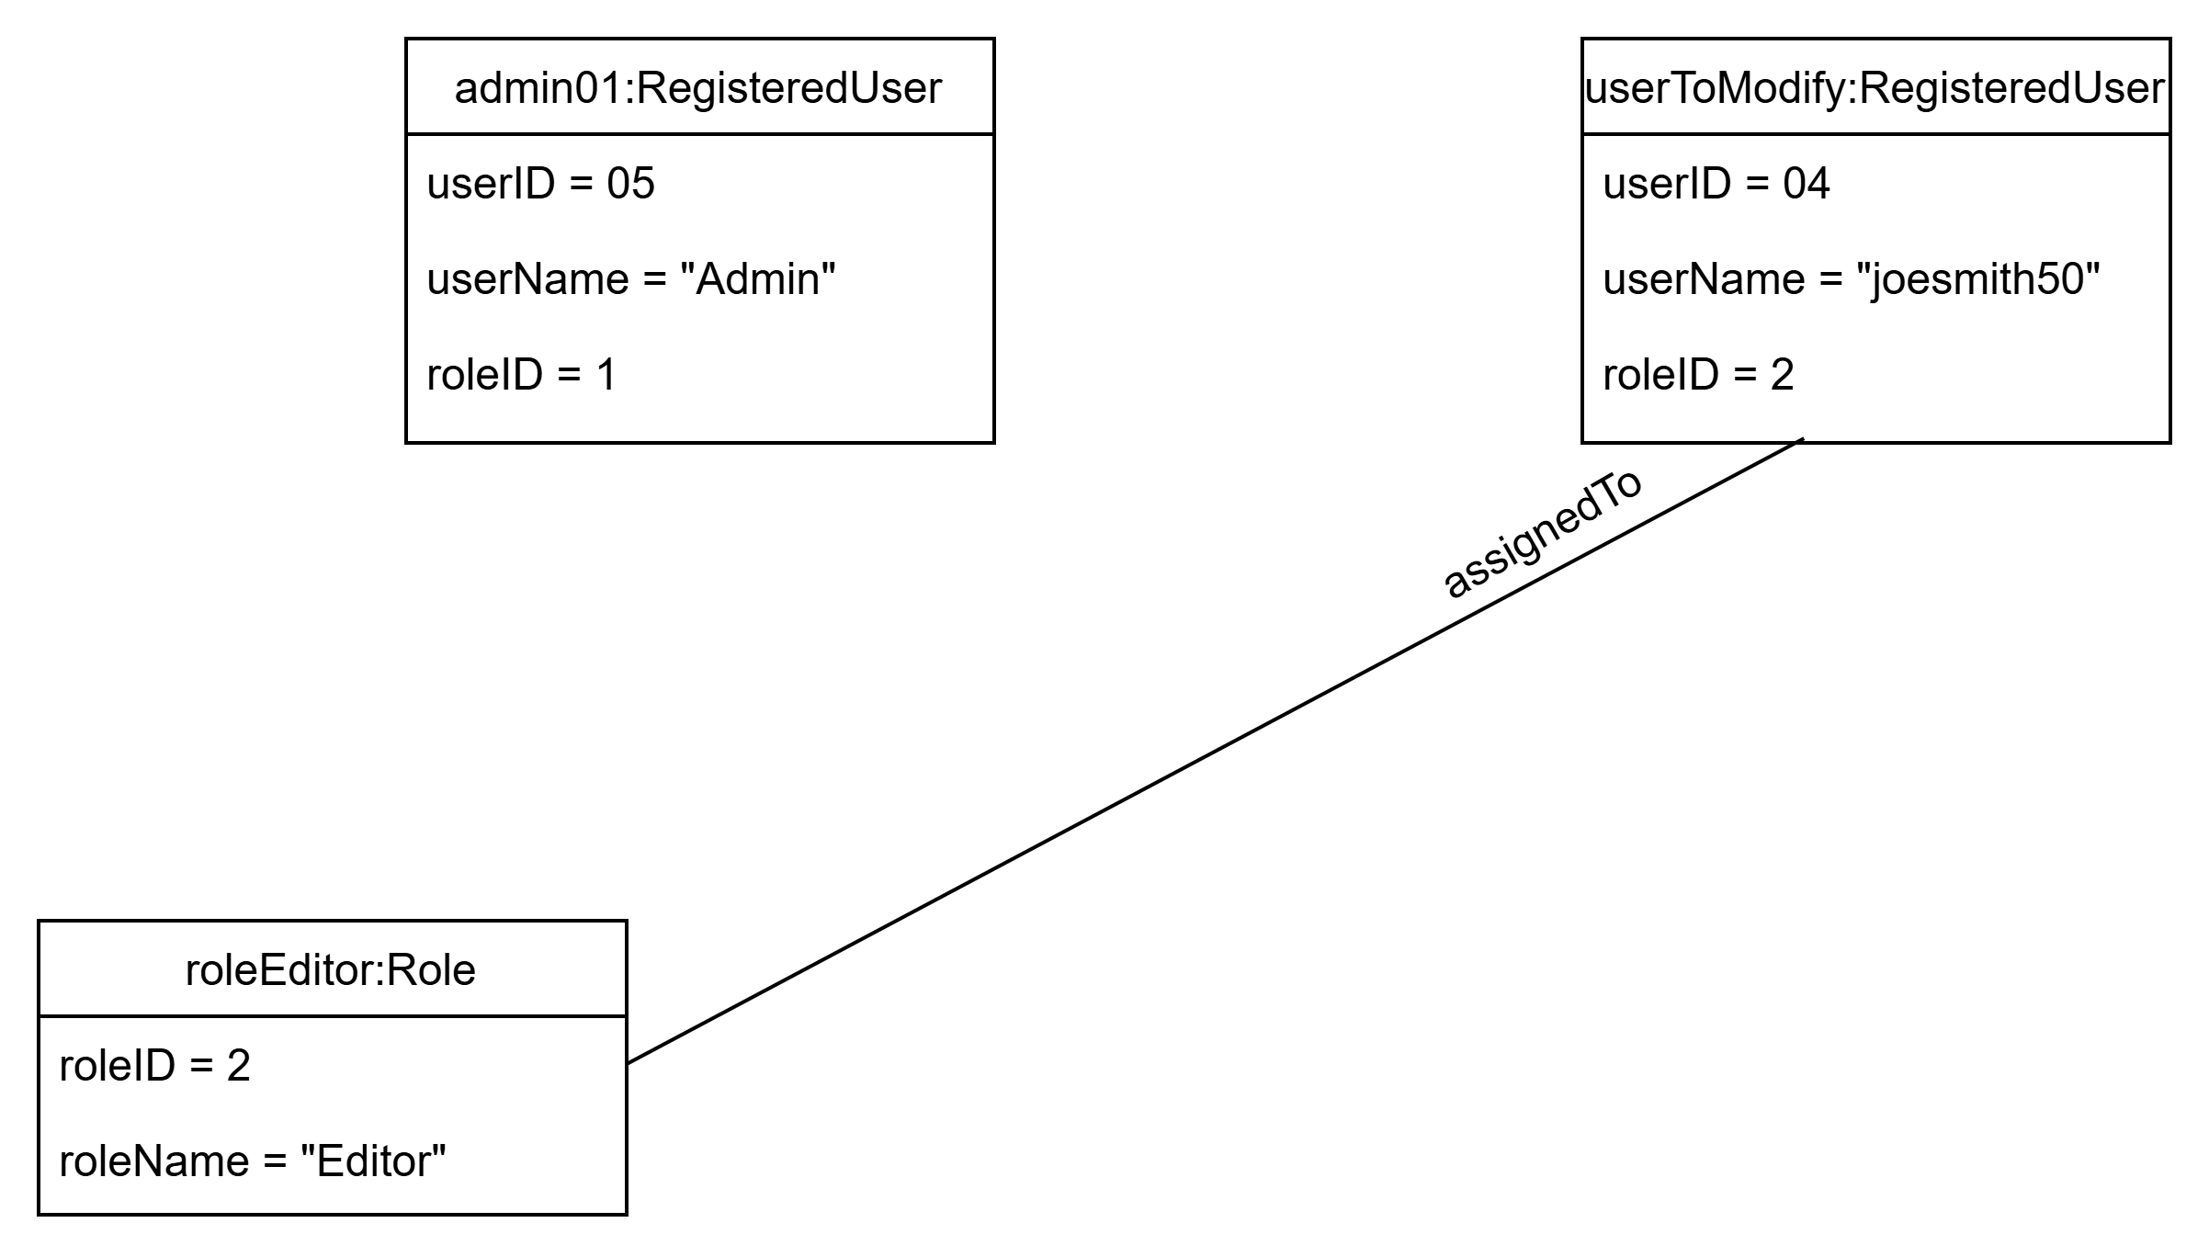

**UC-23 – Manage Users (POSTCONDITIONS)**

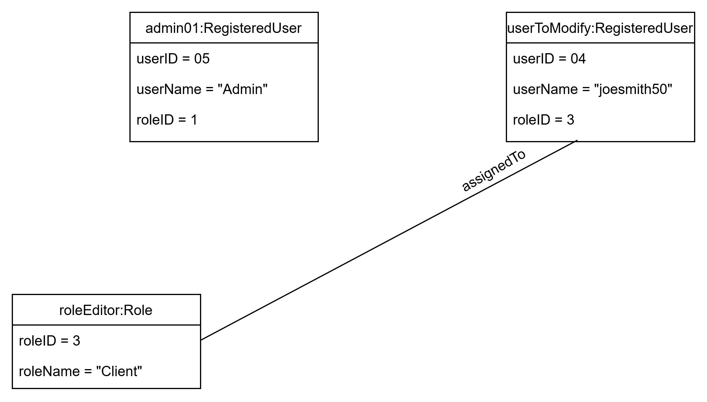

**q) Database Specification (ERD, Tables)**

**Tables)**

